**International Islamic University Chittagong**

**Department of Computer Science and Engineering**



**A Project Report on**

**BD-Tourism: A Web Portal for Tourists**

**Submitted by**

Kalyan Brata Chakraborty - C141008

Md. Arman Uddin Ovi - C141009

Tanmoy Dhar - C141025

**Approval of the Supervisor**

_________________________________

**Dr. Abdul Kadar Muhammad Masum**

**Associate Professor, CSE, IIUC.**

|  |  |
| --- | --- |
| **Table of Contents** |  |
| TITLE PAGE | I |
| APPROVED BY PAGE | II |
| DECLARATION | III |
| DEDICATION | IV |
| ACKNOWLEDGEMENT | V |
| ABSTRACT | VI |

|  |  |  |
| --- | --- | --- |
| **1.** | **INTRODUCTION** | 01-03 |
| 1.1 | Introduction | 01 |
| 1.2 | Overview of the present system | 01 |
| 1.3 | Existing system | 01 |
| 1.4 | Objectives | 02 |
| 1.5 | Project deliverables | 02 |
| 1.6 | Gantt chart | 02 |
| 1.7 | Summary | 03 |
|  |  |  |

|  |  |  |
| --- | --- | --- |
| **2.** | **LITERATURE REVIEW** | 04-05 |
| 2.1 | Introduction | 04 |
| 2.2 | Literature review | 04 |
| 2.3 | Similar systems | 04 |
| 2.4 | Comparisons with our system | 05 |
| 2.5 | Summary | 05 |
|  |  |  |

|  |  |  |
| --- | --- | --- |
| **3** | **METHODOLOGY** | 06-11 |
| 3.1 | Introduction | 6 |
| 3.2 | Methodology | 6 |
| 3.2 | Necessity of methodology | 6 |
| 3.4 | Software development life cycle | 07-10 |
|  | 3.4.1 Feasibility study | 07 |
|  | 3.4.2 Requirement Definition | 09 |
|  | 3.4.3 System specification | 09 |
|  | 3.4.4 System Design | 09 |
|  | 3.4.5 Program design and coding | 09 |
|  | 3.4.6 Testing | 09 |
|  | 3.4.7 Implementation | 10 |
| 3.5 | Software Process Model | 10 |
| 3.5 | Summary | 11 |

|  |  |  |
| --- | --- | --- |
| **4** | **SOFTWARE DESIGN DESCRIPTION** | 12-23 |
| 4.1 | Introduction | 12 |
| 4.2 | Software Design Description | 12 |
| 4.3 | Overall Design | 12-14 |
|  | 4.3.1 Use case diagram | 13 |
|  | 4.3.2 A general Model of software design process | 14 |
| 4.4 | Flow Chart | 15-16 |
|  | 4.4.1  Flow Chart for user | 15 |
|  | 4.4.2  Flow Chart for Admin | 16 |
| 4.4 | Entity Relationship Diagram of BD Tourism | 17 |
| 4.5 | Data flow Diagram | 18-21 |
|  | 4.5.1  Context Flow Diagram | 18 |
|  | 4.5.2  O Level DFD | 19 |
|  | 4.5.3  Level 1 DFD | 20 |
|  | 4.5.4  Level 2 DFD | 21 |
| 4.6 | Activity Diagram | 22-23 |
|  | 4.6.1  Activity Diagram of Admin | 22 |
|  | 4.6.2  Activity Diagram of user | 23 |

|  |  |  |
| --- | --- | --- |
| **5.** | **DATABASE** | 24-29 |
| 5.1 | Introduction | 24 |
| 5.2 | Data Dictionary | 24 |
| 5.3 | Database | 24 |
| 5.4 | Tables of BD Tourism | 24-29 |
| 5.5 | Summary | 29 |
|  |  |  |

|  |  |  |
| --- | --- | --- |
| **6.** | **IMPLEMENTATION** | 30 |
| 6.1 | Introduction | 30 |
| 6.2 | Software Implementation | 30 |
| 6.3 | Snapshots | 30-44 |
|  |  |  |
| **7.** | **TESTING** | 45-49 |
| 7.1 | Introduction | 45 |
| 7.2 | Testing | 45 |
| 7.3 | Objectives of testing | 45 |
| 7.4 | Types of testing | 45-48 |
|  | 7.4.1 White box testing | 45-46 |
|  | 7.4.2 Black box testing | 46-48 |
| 7.5 | Summary | 49 |

|  |  |  |
| --- | --- | --- |
| **8.** | **MAINTENANCE OF THE SYSTEM** | 50-51 |
| 8.1 | Introduction | 50 |
| 8.2 | Maintenance | 50 |
| 8.3 | Classification of maintenance | 50 |
| 8.4 | Description of Maintenance | 51 |
| 8.5 | Summary | 51 |
|  |  |  |

|  |  |  |
| --- | --- | --- |
| **9.** | **CONCLUSION** | 52 |
| 9.1 | Introduction | 52 |
| 9.2 | Project Outcomes | 52 |
| 9.3 | Project Limitations | 52 |
| 9.4 | Future works | 52 |
|  |  |  |

|  |  |
| --- | --- |
| **10. Reference** | 53 |

|  |  |  |
| --- | --- | --- |
| **LIST OF FIGURES** | **Details** | **Page No.** |
| Figure 1.1 | Gantt chart | 02 |
| Figure 3.1 | Software Development Life Cycle (SDLC) | 07 |
| Figure 3.2 | Waterfall Model | 10 |
| Figure 4.1 | Use Case Diagram | 13 |
| Figure 4.2 | A general Model of software design process | 14 |
| Figure 4.3 | Flow Chart for User | 15 |
| Figure 4.4 | Flow Chart for Admin | 16 |
| Figure 4.5 | Entity Relationship Diagram of BD Tourism | 17 |
| Figure 4.6 | Context Flow Diagram | 18 |
| Figure 4.7 | 0 Level DFD | 19 |
| Figure 4.8 | Level 1 DFD | 20 |
| Figure 4.9 | Level 2 DFD | 21 |
| Figure 4.10 | Activity Diagram of Admin | 22 |
| Figure 4.11 | Activity Diagram of User | 23 |
| Figure 6.1 | Home Page Screen | 30 |
| Figure 6.2 | Top Destination | 31 |
| Figure 7.1 | White Box Testing of Our System | 46 |
| Figure 7.2 | Black Box Testing of Our System | 48 |

**CERTIFICATE OF APPROVAL**

The project entitled as “**BD Tourism**” submitted by Kalyan Brata Chakraborty, bearing ID No: C 141008, Md.Arman Uddin Ovi bearing ID No. C141009, and Tanmoy Dhar, bearing ID No: C 141025, to the Department of Computer Science & Engineering (CSE) of International Islamic University Chittagong (IIUC) has been accepted as satisfactory for the partial fulfillment of the requirements for the Degree of Bachelor in Computer Science & Engineering.

Supervised & approved by:

___________________________

Dr. Abdul kadar Muhammad Masum

Associate Professor

Dept. of CSE, IIUC.

International Islamic University Chittagong

I

**DECLARATION**

We hereby declare that the project has been completely done by ourselves under the constant supervision of Dr. Abdul kadar Muhammad Masum, Associate Professor, Department of Computer Science & Engineering, International Islamic University Chittagong. No segment of the work enclosed in this project has been submitted in support of any application for any other degree or qualification of this or any other university or institute of learning.

**Signature of students:**

(Kalyan Brata Chakraborty)

(Md.Arman Uddin Ovi)

(Tanmoy Dhar)

II

**DEDICATION**

THIS PROJECT IS DEDICATED TO OUR PARENTS

&

ALL OF OUR LOVED ONES

III

**ACKNOWLEDGEMENT**

At first, we would like to express our sincere thanks and gratitude to our advisor Dr. Abdul kadar Muhammad Masum for his excellent guidance and motivation behind our web application project BD-Tourism: A Web Portal for Tourists. This kind encouragement, compassionate and invaluable detailed suggestion and supervision throughout the phases of project development, presentation, and paper organization have helped us to successfully accomplish the paper.

Finally, we are sincerely grateful to our parents, family, and friends, who give their valuable suggestions and support to complete the project. The whole research work would not be possible without the active encouragement from all of them.

Kalyan Brata Chakraborty

Md.Arman Uddin Ovi

Tanmoy Dhar

IV

**ABSTRACT**

Our project **BD Tourism** is based on Web application.

The objective of this project is to provide greater facilities to all the people basically those who are opting to travel tourist spots all over the country. Its main target is to improvise the Travel recommendation system. Despite having a lot of tourist attractions in our country, there are seldom any handy and reliable application to supervise the tourists right from the very beginning of the journey which includes the transport to the end. Our project focuses on direction to easy route to destination along with the related accommodation and meal spots.

V

**Chapter One**

**INTRODUCTION**

**1.1 Introduction:**

The huge amount of information about tourism available on the Web has turned the preparation of a trip into a very challenging task, ripe for the application of recommender systems. Travelers are very keen on using tools that may support their decision making processes when they are planning a travel, including the choice of destination, the selection of attractions to visit, the construction of a multi-day plan, the suggestion of appropriate accommodations and restaurants etc.

Tourists Recommendation system is a Web-based recommender system that computes a user-adapted tourist plan for user. Recommends a list of activities to perform in a city, Agenda of activities, time schedule for the list of activities taking into account and Distances between places, hours, Hotel booking activities, Vehicle Services etc.

We were trying to develop a web based application for tourists in context of Bangladesh that generates recommendations about personalized tourist tours in Bangladesh. It is intended to be a service for foreigners and locals to become deeply familiar with the places and plan leisure activities. BD-Tourism makes recommendations based on the user's age, tastes, his demo-graphic classification, the places visited by the user in former trips and, finally, his current visit preferences. One of the main components of BD-Tourism is the planning module which is aimed at scheduling the recommended activities according to their age, budget, duration, travel time of the places to visit and the geographical distances.

**1.2 Overview of the present system:**

The existing Tourism projects is not generally recommender system at all. It is not effective as the system is very time consuming and manpower for performing various tasks. Sometimes it leads to a great loss as well headache for tourists.

**1.3 Explanation of the existing system:**

There are many tourist applications and websites that provide facilities like places, accommodations etc. about several places. These systems only provide static information that is mostly already known and provide just numbers and directions to it .Systems working on tourist systems are: makemytrip.com: Created to empower the traveler with instant booking and effective choices, Tripigator: Tired of paper travel guides and big maps that nobody understands, TouristEye: With a much clearer focus in the process of planning the trip, Previous student of our University work on Modern Tourism: Tried to provide information to the user by using map, place description, distance etc. Amount of the overall trips are kept in the calculations done are manually which made lead to huge mistakes that makes User complicated.

**1.4 Objectives of the system:**

The purpose of this system is to create a personalization tool that recommends a person a list of information items that best fit his/her individual tastes. A recommender system infers the user preferences by analyzing the available user data, information about other users and information about the environment. The adequacy of the recommendations highly depends on the amount of available information. The system is integrated into a web service and so recommendations must be calculated in real time.

The main aim of this project is to develop a web portal for tourist in context of Bangladesh.

**1.5 Project Deliverables:**

* Our Tourism application is developed taking all the measures to make the user more informatics and to give the benefit of enjoy the tour.
* All the operations like searching, plan, bookings, and other related things are automated which leads to saving time and effort.
* It provides real time information which is needed anytime and anywhere.
* Collaborate with transport and booking providers for making a good service for its users.
* Reduces the manpower needed for controlling the present system and to provide the best efficiency.

**1.6** **Gantt Chart**

To complete this project, we have some roles and responsibility. and if we want to complete this within due time, we should maintain the roles and responsibility.

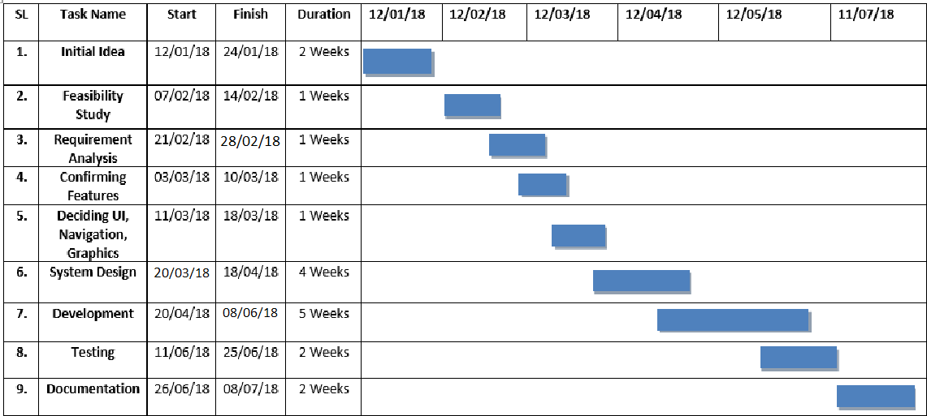

Figure 1.1: Gantt chart

**1.7 Summary**

We have discussed about the objective of the system, overview of the present system, explanation of the present system and the proposed system in the chapter. The system will benefit the whole tourism business.

**Chapter Two**

**Literature Review**

**2.1 Introduction:**

This chapter mentions about literature review of our system, definition of literature review, similar system and comparison of our system.

**2.2 Literature review:**

A literature review is the effective evaluation of selected documents on a research topic. A review may form and essential part of the research process or may constitute a research project in itself. In the following literature review we will discuss about some existing systems which are partially similar to our project.

**2.3 Similar systems:**

Before developing our system, we had studied some systems which are partially related to our system. There are some systems which are partially similar to our system. They might look similar to our project but the functionalities are different. The systems we had studied are Bangladesh travel guide, makemytrip, tripadvisor, Lonelyplanet, Yatra.com,Travelguru

Bangladesh Traveler's Guide provide basic information such as time zones, safety, visas and so on. We are sure that this travel guide to Bangladesh will contribute to a pleasant stay in this fascinating country.This is more likely just an informative app. All are static content [1]. MakeMyTrip.com, India’s leading online travel company which was Created to empower the traveler with instant booking and effective choices. It is also providing international and domestic air tickets, holiday packages and hotels, domestic bus and rail tickets, private car and taxi rentals and affiliate services [2]. TripAdvisor provides travelers with the wisdom of the crowds to help them decide where to stay, how to fly, what to do and where to eat. TripAdvisor also compares prices from more than 200 hotel booking sites so travelers can find the lowest price on the hotel that's right for them [3]. Lonely Planet never recommend travelers visit a destination that isn’t ready for tourism and their guidance provides travelers with the information require to make an informed decision and to be aware of any ethical concerns in a destination. Lonely Planet produces millions of books and magazines each year [4]. Yatra.com, the first top for travel agents, corporate frequent flyers and casual backpackers alike, is a premium travel site in India. By logging into Yatra.com, users can be assured of getting the best prices and cashback deals on their air, train and bus bookings; hotel and accommodation facilities; holiday packages; etc [5]. Travelguru.com, often rated as one of the most visited Indian travel sites online, is a treasure house of treats when it comes to booking air tickets, hotel facilities [6] .

**2.4 Comparisons with our system:**

In this section we will make a comparison of the following system with our system. In the previous section we saw that the systems has issues with various contents such as recommendation system, communication etc. In our system we have made a proper system for tourists where tourists can get actual information of their destination place. Besides in our system we have put a option named “Blog”, in that option users can make a post with their tourist experience. Our system is suitable for real time information which is needed anytime and anywhere. Some do not have the option as different system has different functionalities. But in our systems we have merged these options so it also differs our system from others. In our system we are trying to give proper information based of the user budget. We are trying to give the plan based on the user budget. User can find transport and hotels of their destination place. User can rate the packages by their experience. We are trying to recommend the full package. In our application user can book the full package based on their budget.

**2.5 Summary:**

In this Chapter, we describe the literature review and similar application of our system. We also describe about comparisons with our system.

**Chapter Three**

**METHODOLOGY**

**3.1 Introduction:**

This chapter mentions about methodology, necessity of methodology, software development life cycle (SDLC), software Process model and others.

**3.2 Methodology:**

A methodology is a system for structuring, planning and controlling the processes of developing a system. Methodology defines the different associates use in the making of the software.

Administrators utilize a basic procedure for organizing the conveyance of the framework. Our task is BD Tourism. Without a technique, we would be neither focused nor effective. There are most regular dangers and difficulties related with the frameworks incorporation. We expect those dangers and difficulties simply because we have a procedure set up which, when pursued, ensures achievement.

To create software, engineers need to pursue some system. In our venture we pursue system development life cycle (SDLC) approach. Since utilizing this strategy we can do our work well ordered and planned insightful. system development life cycle (SDLC) is a procedure of seeing how a framework can be upheld if business needs, plan the framework, creating it and conveying it to clients. It incorporates five stages which are:

* Planning
* Analysis
* Design Physical
* Design Logical Design
* Implementation
* Maintenance

**3.3 Necessity of methodology:**

Methodology is required for software so it creates with capability. We will present a philosophy which contains the means for building up our task contingent upon proposed system. With the end goal to build up the BD Tourism, we require an approach. A propelled system development life cycle (SDLC) is the best possible system.

**3.4 Software Development Life Cycle (SDLC):**

For BD Tourism, we follow SDLC to make specific for the user.

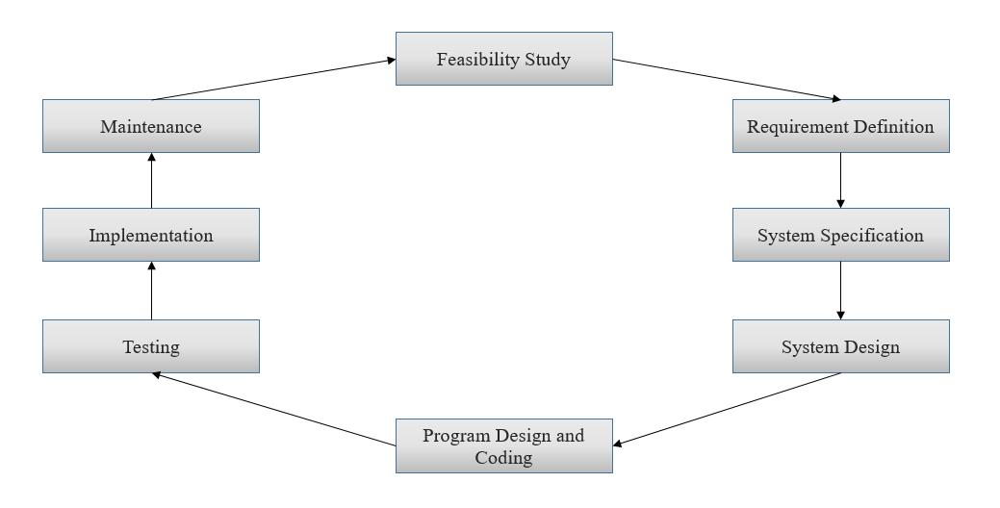

Fig 3.1: Software Development Life Cycle (SDLC)

**3.4.1 Feasibility Study:**

Feasibility study is a test of system proposition as per its usefulness, effect of the association, capacity to address issues and viable utilization of assets. Amid possibility examination for this task, following essential regions of intrigue are to be considered. Examination and producing thoughts regarding another framework does this. Ventures in achievability investigation:

* For a project team.
* Create system flowchart.
* Enumerate potential proposed system.
* Defined & evaluate performance and cost effective of each proposed system. Select best proposed system.
* Prepare and report final project direct to management.

**3.4.1.1 Technical Feasibility:**

A study of resources availability that may affect the ability achieve an acceptable system. This evaluation determines whether the technology needed for the proposal system is available or not. The technical needs of the system may include:

Front end selection

* Feasibility
* Robustness
* Easy to debug and maintain
* Must have a GUI that assists user who is not from IT background.
* Scalability and extensibility

We have selected HTML, CSS, JavaScript, JQuery and Bootstrap as our front end. Back end selection

* Efficiently data handling
* Efficient data retrieval and maintenance
* Easy to install
* Compatible

We have selected Codeigniter, MySQL as our back end.

**3.4.1.2 Economic Feasibility:**

Economic declaration is gradually the down line consideration for several systems. Financial defense incorporates a wide scope of worries that incorporates money saving advantage examination. In this we weight the expense of advantages related with the applicant framework and on the off chance that it suits the fundamental motivation behind the association i.e. benefit making, the task is making to the examination and configuration stage.

The financial and economic questions during the preliminary investigation are verified to estimate the following:

* The cost to conduct a full system investigation.
* The cost of hardware and software for the class of application being considered.
* The benefits in the form of reduced cost.
* This feasibility detects whether the system can be created with the available funds. The BD Tourism does not require several amount of money to be developed. This can be done economically if planned specially, so that it is economical feasible.

**3.4.1.3 Operational Feasibility:**

It is mainly related to human organizations and political field. The points to be considered are:

What changes will be made with the system?

What if organization structures are disturbed?

The system is operationally feasibility as it is easy for the End users to operate it. It only needs the basic information about Windows platform.

**3.4.1.4 Schedule Feasibility:**

Time evaluation is the most necessary aspect in the development of project. Time plan required for the improvement of this venture is critical since greater advancement time impact machine time, cost and cause delay in the improvement of other framework.

**3.4.2 Requirement Definition:**

At this step, we have to develop system requirements by using well known requirement engineering tests. Requirement engineering has three parts that are:

* Requirement Analysis
* Requirement Specification
* Requirement Validation

**3.4.3 System Specification:**

At this segment we focus in ER-Diagram which shows the entity, attribute and relationship with involving one to one, one to many, many to many, assign primary keys, foreign keys and perform normalizations to reduce redundancy.

**3.4.4 System Design:**

In this segment system design work with two part that are overall and detailed design. By and large plan characterizes the structure of structure of the product. Detail configuration completed the entire program of the framework in which it characterizes the handling. Our framework necessity converts into this and we have planned our system.

**3.4.5 Program design and coding:**

In this step discussed about the programming languages that are using in proposed system.

We used well known HTML, CSS, JS, JQuery, Bootstrap, PHP-Codeigniter, MySQL etc.

for our project. Here the layer architecture is followed for program design.

**3.4.6 Testing:**

To develop a system testing is most important. Testing is a process of findings faults.

Testing can be implemented in our proposed by ways:

White Box Testing: In White Box Testing we tested internal structure of the project just like as coding entry.

**3.4.7 Implementation:**

Numerous product are made for BD Tourism yet we attempted to added couple of new highlights to make adaptable utilization of the clients. I utilized the social database to solid, recovering information for client and looking wind up dependable and less demanding. In execution of the framework plan and coding stage are vital.

**3.5 Software Process Model:**

Developing the BD Tourism, we follow the water fall model.

**3.5.1 Waterfall Model:**

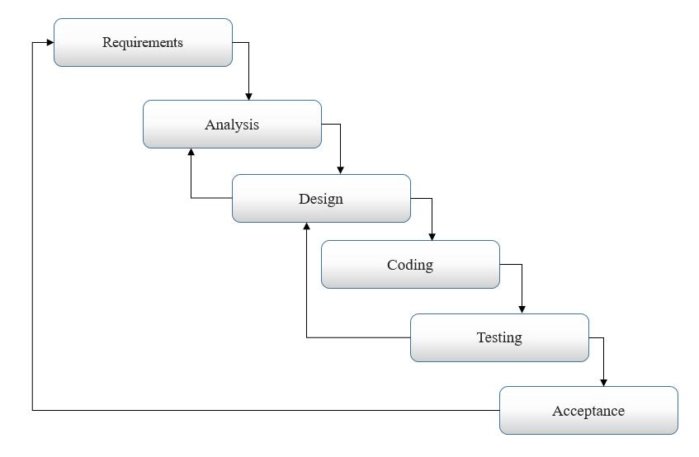

Fig 3.2: Waterfall Model

**3.6 Summary:**

In this Chapter, we describe the process model of our system. We use this waterfall model because it is easily understanding about the requirement needed for the system. We must follow SDLC to develop our system.

**Chapter Four**

**SOFTWARE DESIGN DESCRIPTION**

**4.1 Introduction:**

This chapter mentions about software design description, use case diagram, general model of software design process, Data flow diagram, Entity relationship diagram, Activity diagram, Flow chart and others.

**4.2 Software Design Description:**

Software design is a procedure to upgrade the graphical structure of the product prerequisites and all the agent parts of the product. It additionally decided about the relating engineering plan of the product. The extensive variety of structure of the product can be delineated through the product plan depiction. It is important to have the graphical portrayal of the product to discover which highlights are the place in the product.

Software design description or SDD is a method to specify the architectural system and design of the application of a software. The purpose of the Software design description are:

* Determination of the functional data structure and algorithms to be implemented.
* Identification of the resources of the system.
* Assessing the impact of the several requirements which has to be changed.
* Assisting in the producing test case.
* Verifying contact with requirements.

**4.3 Overall Design:**

**4.3.1 Use case diagram:**

A use case is simple method which is used to identify and organize system requirements in system analysis. This method is made up the possible sequences of interactions between the systems and users in a particular goal.

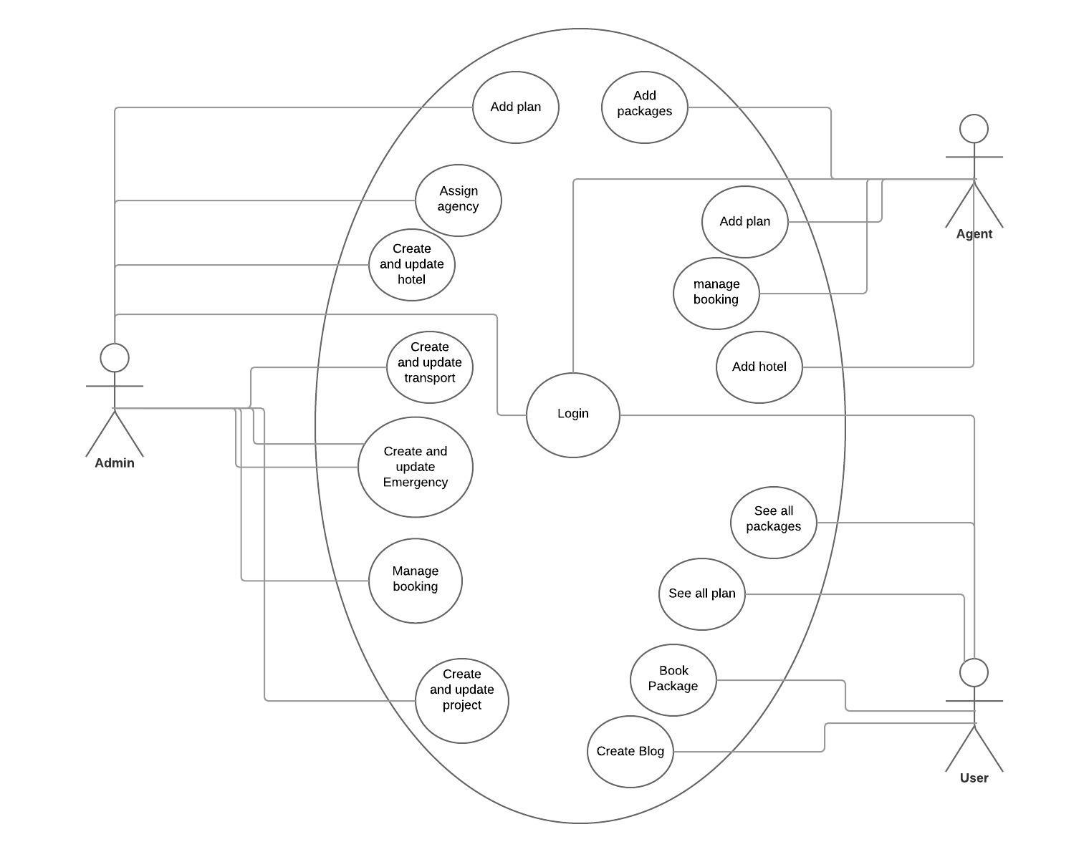

Fig 4.1: Use Case Diagram

**4.3.2 A general model of software design process**

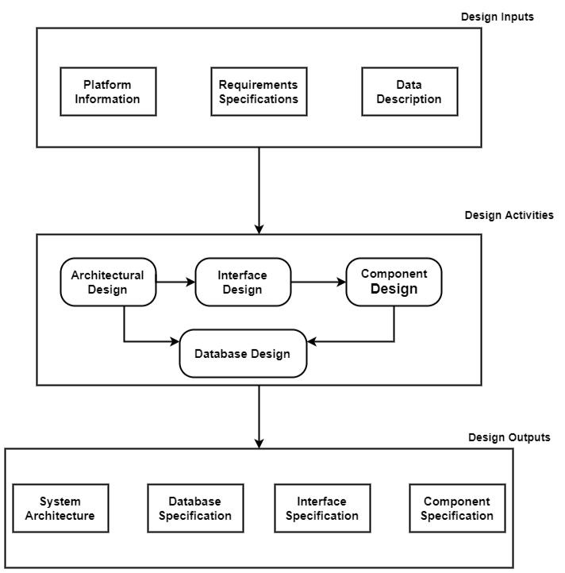

Figure 4.2: A general Model of software design process

**4.4 Flow Chart**

A flow chart is a graphical or symbolic representation of process. The flow chart symbols are linked together with arrows showing the process flow direction.

**4.4.1 Flow Chart for user:**

Start

Validation Check

Login / Registration

Make a plan, See hotel, See blog post, Top destination

NO

YES

Make a plan, See hotel, See blog post, Top destination,

Booking Hotel

Transport booking, See packages, Post a blog, Comment in blog.

Log Out

End

Figure 4.3: Flow Chart for User

**4.3.2 Flow Chart for Admin**

**Start**

**Log In**

**No**

**Validation Check**

**Yes**

**Admin Panel**

**Manage System**

**Log Out**

**End**

Figure 4.4: Flow Chart for Admin

**4.4 Entity Relationship Diagram of BD Tourism**

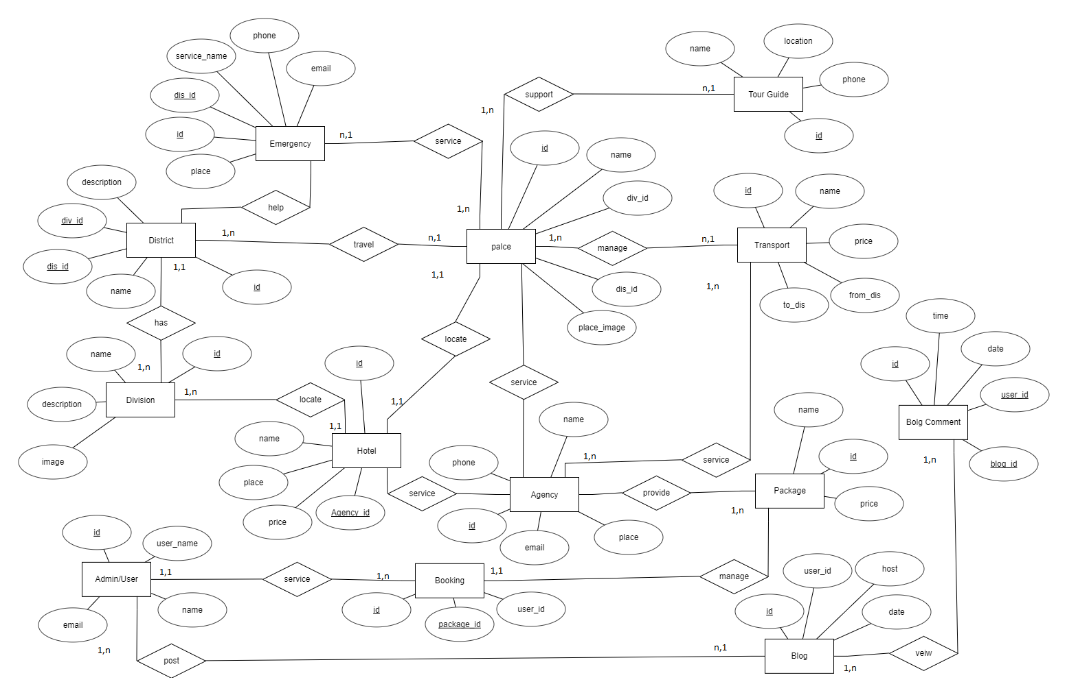

Figure 4.5: Entity Relationship Diagram of BD Tourism

**4.5 *Data flow Diagram***

**4.5.1 Context Flow Diagram**

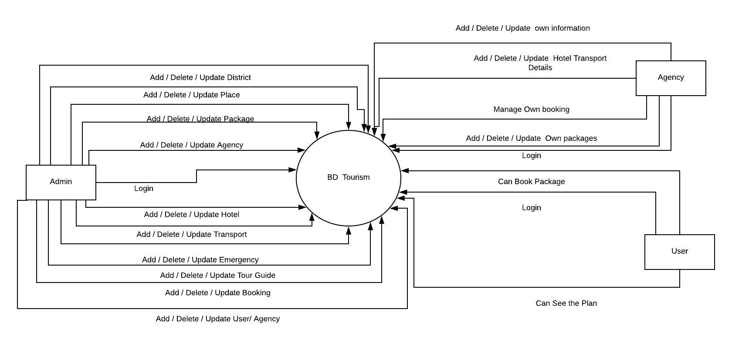

Fig 4.6: Context Flow Diagram

**4.5.2 O Level DFD**

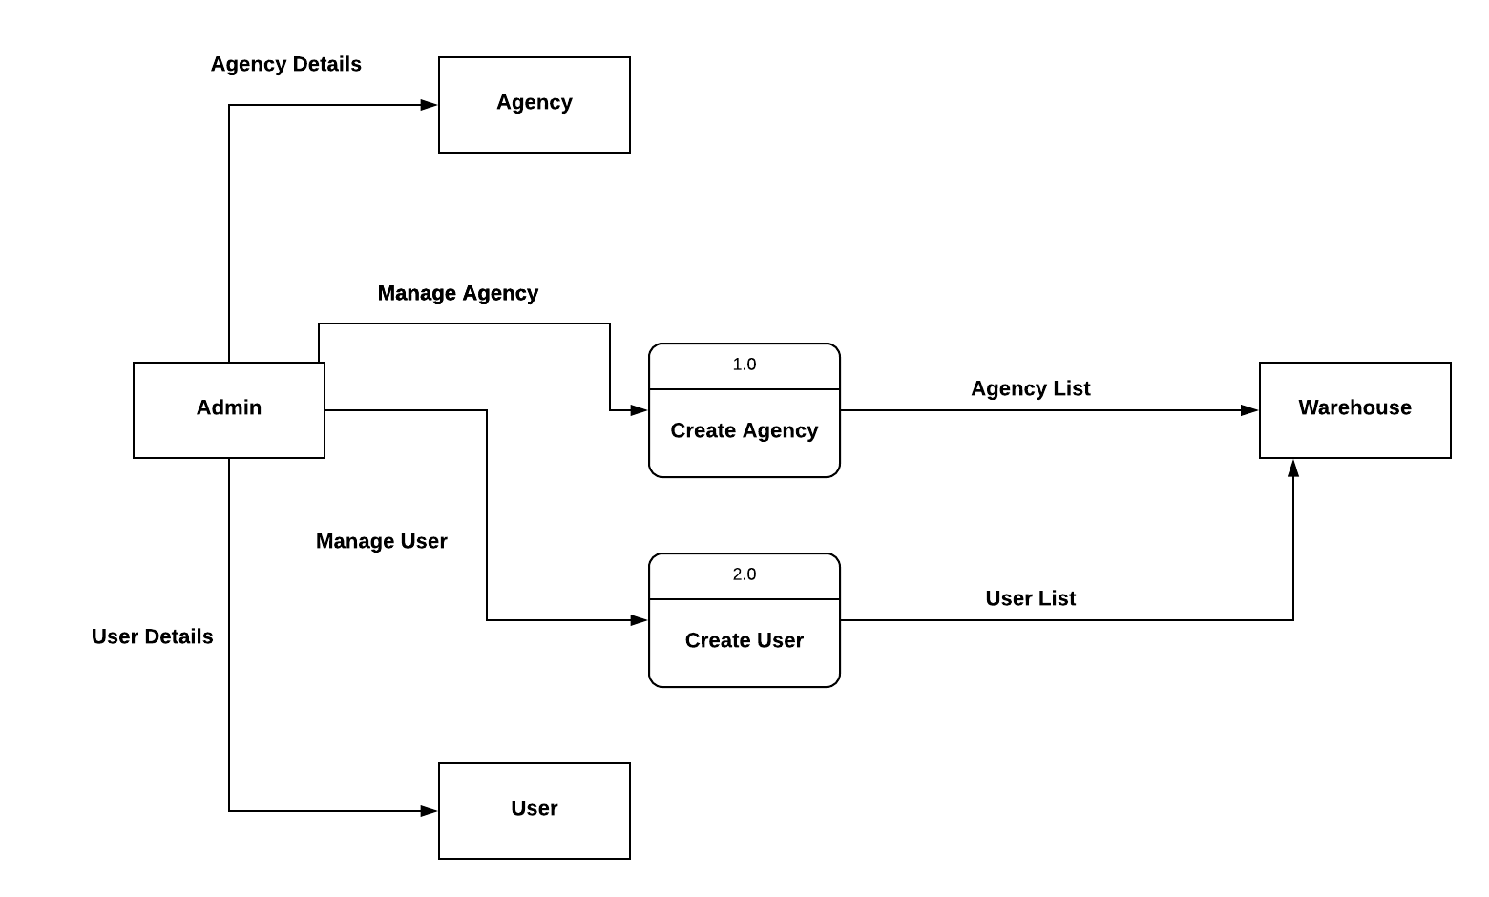

Fig 4.7: 0 Level DFD

**4.5.3 Level 1 DFD**

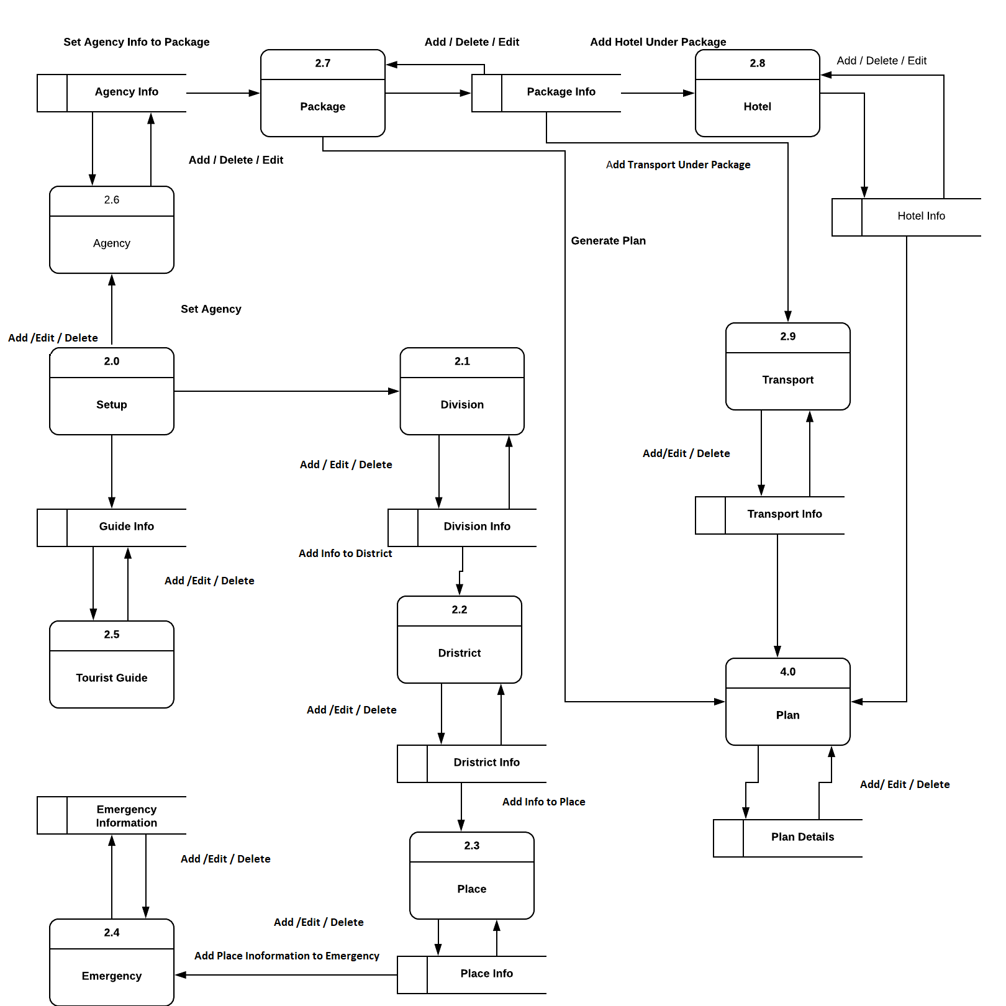

Fig 4.8: Level 1 DFD

**4.5.4 Level 2 DFD**

Fig4.9: Level 2 DFD

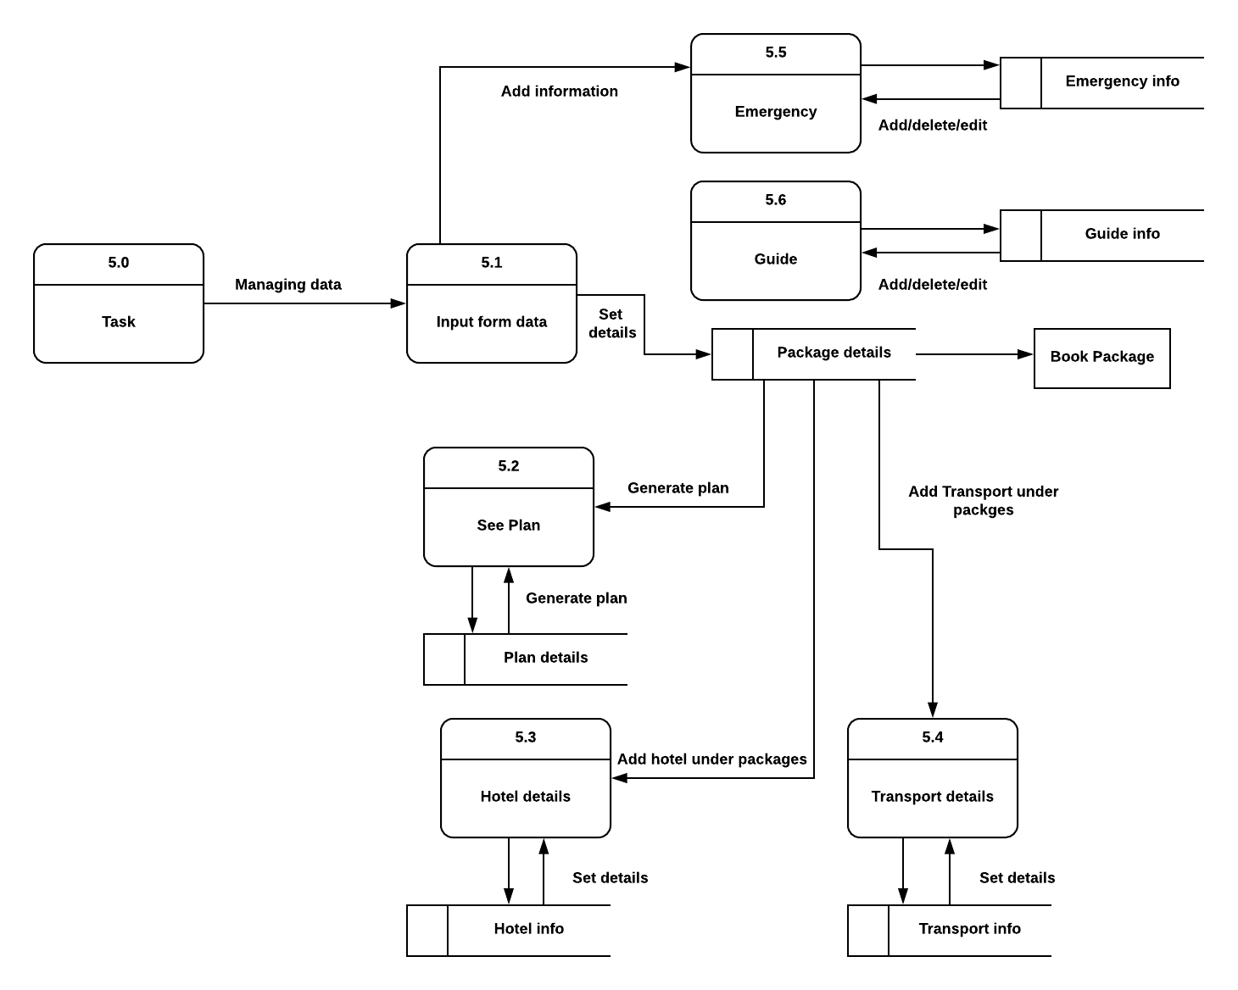

**4.6 Activity Diagram**

**4.6.1 Activity Diagram of Admin**

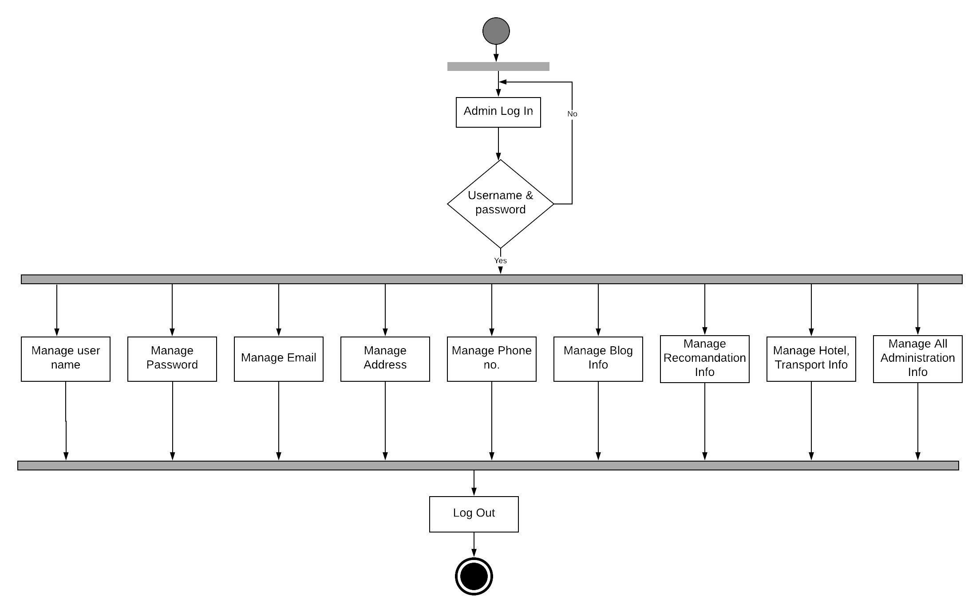

Figure 4.10: Activity Diagram of Admin

**4.6.2 Activity Diagram of Users**

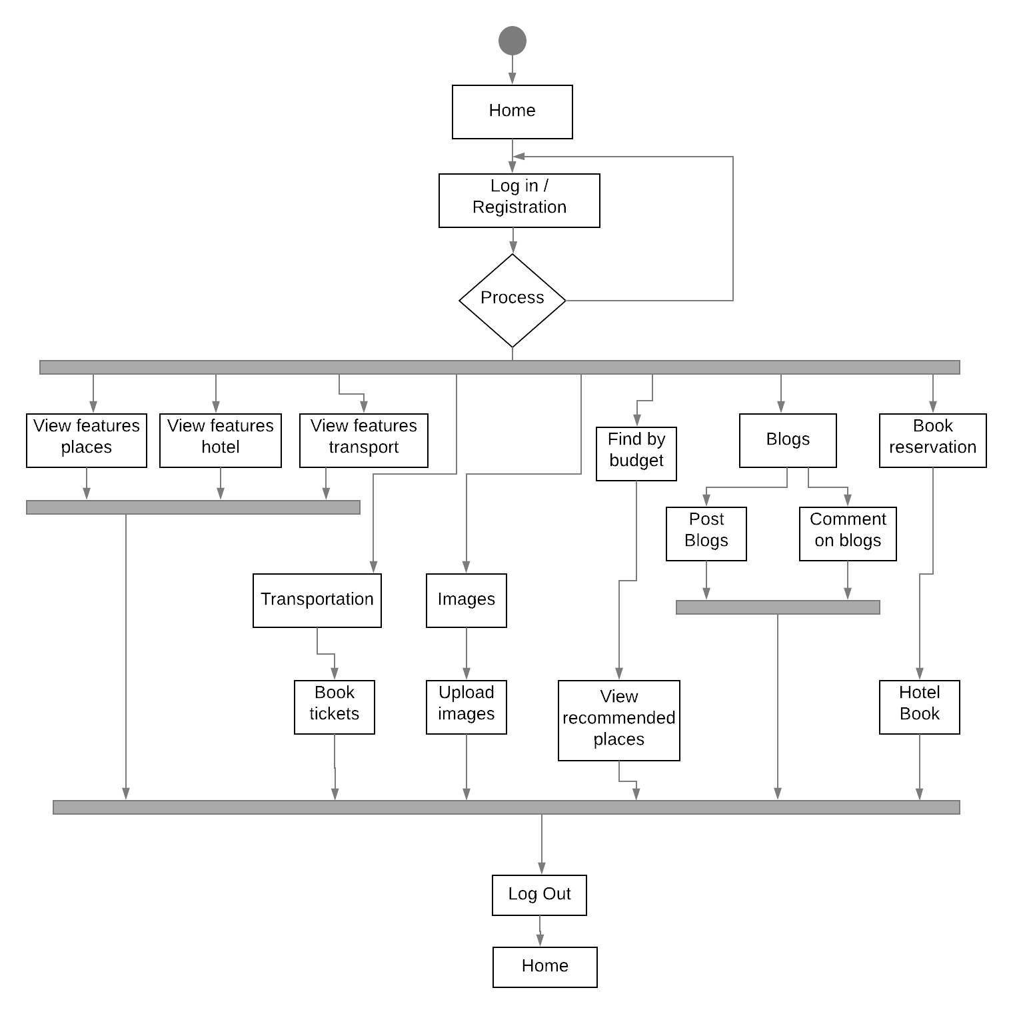

Figure 4.11: Activity Diagram of User

**Chapter Five**

**DATABASE**

**5.1 Introduction:**

This chapter mentions about the database of our system. In this chapter we give all the

Database table information of our system.

**5.2 Data Dictionary:**

Data Dictionary and Data storage is used to define a more simple software utility than a catalogue. An index is firmly combined with the DBMS programming; it gives the data put away in it to client and the DBA, yet it is by and large access by the different programming modules of the DBMS, for example, DDL and DML compilers, the inquiry streamlining agent, the exchange processor, report generators, and the imperative master. Then again, a Data Dictionary is an information structure that stores meta-information, i.e.; information about information. The product bundle for a remain solitary Data Dictionary or Data Repository may collaborate with the product modules of the DBMS, however it is fundamentally utilized by the Team individuals, Users and Admin of a PC framework for data asset administration. These systems are used to maintain information on system hardware and software configuration, documentation, application and users as well as other information 0relevant to system administrator of the correlated system.

**5.3 Database:**

Database is the collection of data which can be merely add, edit or delete any kind of data.

**5.4 Database management system:**

Database management system is the collection of corelated data and a set of functions to access data. The objective of DBMS is to create, query, update and administrate the data of database.

**5.5 Tables of BD Tourism:**

5.5.1 tbl_admin

|  |  |
| --- | --- |
| **Field** | **Type** |
| Id | int(11) |
| Name | varchar(155) |
| Username | varchar(155) |
| Email | varchar(100) |
| Password | varchar(200) |
| Image | varchar(155) |
| Role | varchar(100) |
| Status | tinyint(4) |

5.5.2 tbl_agency

|  |  |
| --- | --- |
| **Field** | **Type** |
| Id | int(11) |
| District_id | Int(11) |
| Place | varchar(155) |
| Location | Text |
| Name | varchar(155) |
| Email | varchar(155) |
| Phone | varchar(20) |

5.5.3 tbl_blog

|  |  |
| --- | --- |
| **Field** | **Type** |
| Id | int(11) |
| user_id | Int(11) |
| Post_title | varchar(100) |
| Date | date |
| Post | text |
| Time | varchar(50) |

5.5.4 tbl_blog_comment

|  |  |
| --- | --- |
| **Field** | **Type** |
| Id | int(11) |
| blog_id | int(11) |
| Comment | Text |
| user_id | int(11) |
| Date | Date |
| Time | varchar(50) |

5.5.5 tbl_blog_image

|  |  |
| --- | --- |
| **Field** | **Type** |
| Id | int(11) |
| Image | varchar(155) |
| blog_id | int(11) |

5.5.6 tbl_booking

|  |  |
| --- | --- |
| **Field** | **Type** |
| Id | int(11) |
| package_id | int(11) |
| Place | varchar(155) |
| Name | varchar(155) |
| Email | varchar(155) |
| Mobile | varchar(20) |
| hotel_id | int(11) |
| Stay | int(11) |
| from_district | int(11) |
| transport_id | int(11) |
| Seats | int(11) |
| Date | Date |
| Token | int(11) |

5.5.7 tbl_blog_district

|  |  |
| --- | --- |
| **Field** | **Type** |
| Id | int(11) |
| div_id | int(11) |
| Name | varchar(200) |
| Description | Text |
| Image | varchar(200) |

5.5.8 tbl_blog_division

|  |  |
| --- | --- |
| **Field** | **Type** |
| Id | int(11) |
| Name | varchar(200) |
| Description | Text |
| Image | varchar(200) |

5.5.9 tbl_emergency

|  |  |
| --- | --- |
| **Field** | **Type** |
| Id | int(11) |
| district_id | int(11) |
| Place | varchar(155) |
| Location | text |
| service_name | varchar(155) |
| Phone | varchar(50) |
| Image | varchar(25) |

5.5.10 tbl_guide

|  |  |
| --- | --- |
| **Field** | **Type** |
| Id | int(11) |
| district_id | int(11) |
| Place | varchar(155) |
| Location | text |
| service_name | varchar(155) |
| Phone | varchar(50) |
| Image | varchar(25) |
| Experience | varchar(255) |

5.5.11 tbl_hotel

|  |  |
| --- | --- |
| **Field** | **Type** |
| Id | int(11) |
| agency_id | int(11) |
| package_id | int11) |
| division_id | int11) |
| district_id | int11) |
| Place | varchar(155) |
| Location | text |
| Name | varchar(155) |
| Description | Text |
| Price | double(25,3) |
| Image | varchar(255) |

5.5.12 tbl_package

|  |  |
| --- | --- |
| **Field** | **Type** |
| district_Id | int(11) |
| Place | varchar(155) |
| no_of_days | int(11) |
| max_budget | decimal(18,3) |
| max_adult | int(20) |
| max_children | int(11) |
| Description | text |
| Image | varchar(155) |
| Rate | double(8,2) |
| Click | int(11) |
| avg_rating | Double(8,2) |

5.5.13 tbl_place

|  |  |
| --- | --- |
| **Field** | **Type** |
| Id | int(11) |
| Name | varchar(155) |
| Description | text |
| division_id | int(11) |
| district_id | int(11) |
| Rating | int(11) |

5.5.14 tbl_place_image

|  |  |
| --- | --- |
| **Field** | **Type** |
| Id | int(11) |
| image | varchar(155) |
| Place_id | int(11) |

5.5.15 tbl_plan

|  |  |
| --- | --- |
| **Field** | **Type** |
| id | int(11) |
| package_id | int(11) |
| division_id | int(11) |
| district_id | int(11) |
| place | varchar(155) |
| location | varchar(155) |
| description | text |
| no_of_days | int(11) |
| maximum_age | int(11) |
| is_children_allowed | tinyint(4) |

5.5.16 tbl_transport

|  |  |
| --- | --- |
| **Field** | **Type** |
| id | int(11) |
| agency_id | int(11) |
| package_id | int(11) |
| from_district | int(11) |
| to_district | int(11) |
| name | varchar(155) |
| price | double(18,3) |
| available_seats | int(11) |
| going_time | varchar(155) |
| image | varchar(155) |

**5.6 Summary:**

In this chapter we discussed about data dictionary, database management system and tables of BD Tourism.

**Chapter Six**

**IMPLEMENTATION**

**6.1 Introduction:**

This chapter mentions about the implementation of our system. In this chapter we gives all the information of our system. which language and technology we use in this system all are given in this chapter.

**6.1 Software Implementation:**

We implement our software using given below:

* HTML
* CSS
* JavaScript
* JQuery
* Bootstrap
* MySQL
* Codeigniter

**6.2 Snapshots:**

**Home Page:** User can see the view of the home page. In home page user can sign in or sign up in the website. User can see the plan of the packages.

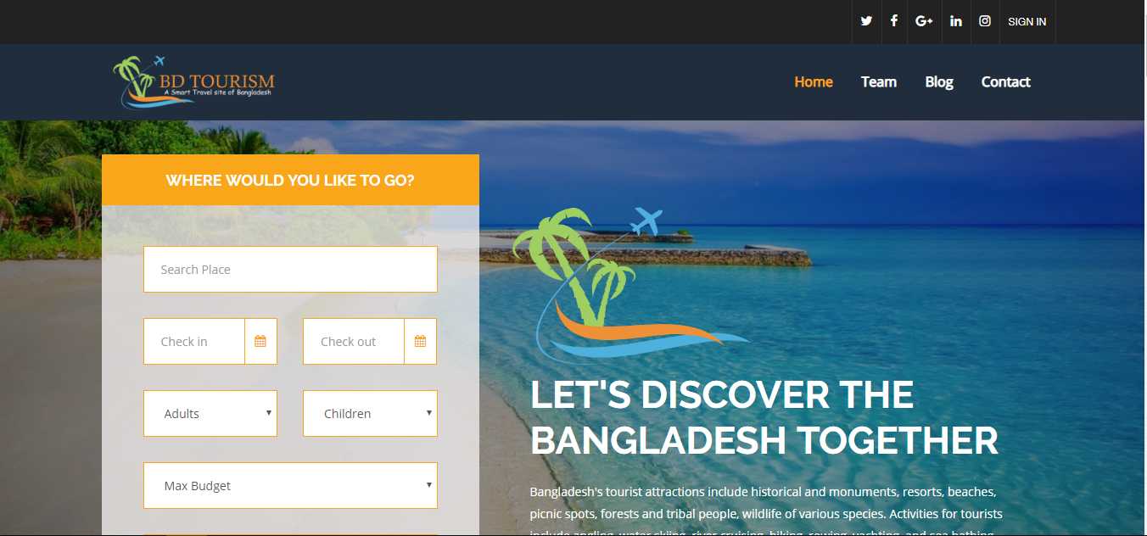

Figure 6.1: Home page

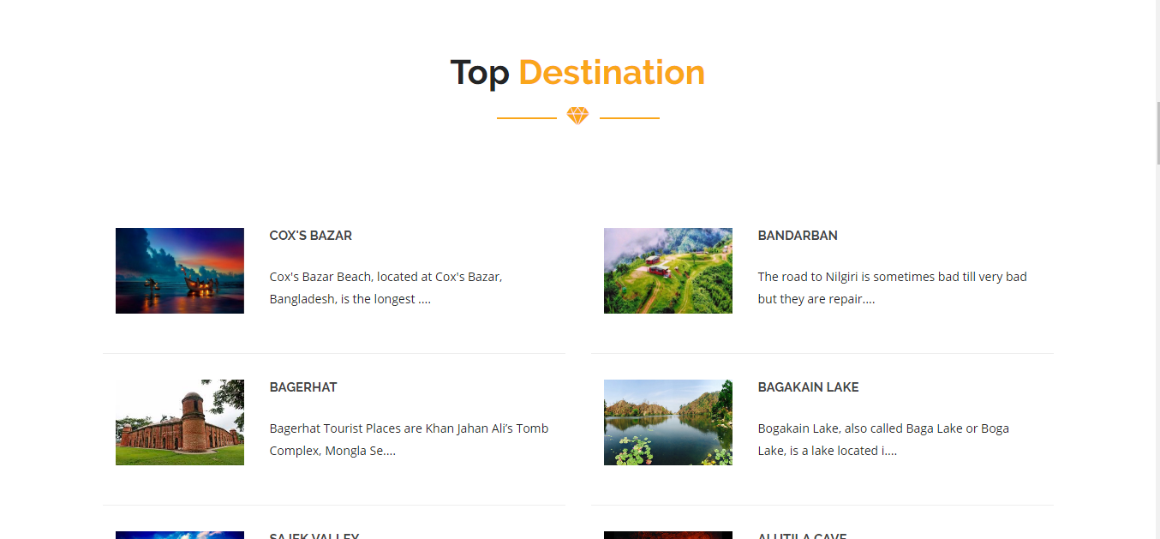**Top Destination:** User can see the top destination of the webpage and find out the best places which are the best for them. Which help them to find out the best places.

Figure 6.2: Top Destination

**Packages Page:** In this page user can see their best packages. And then user can chose their best packages which is best for them

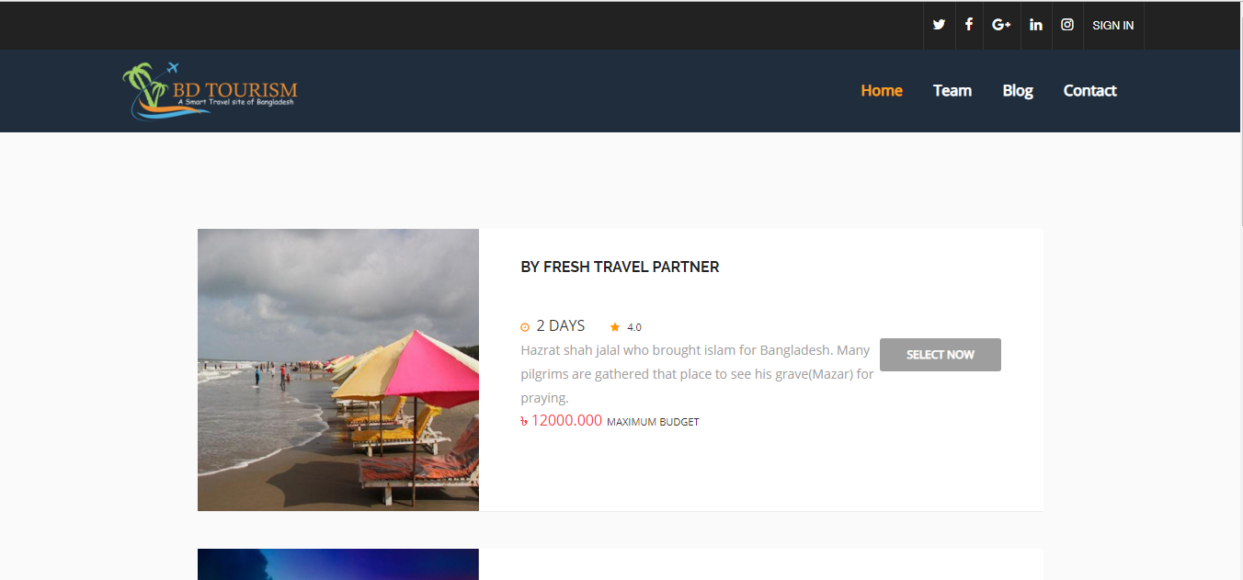

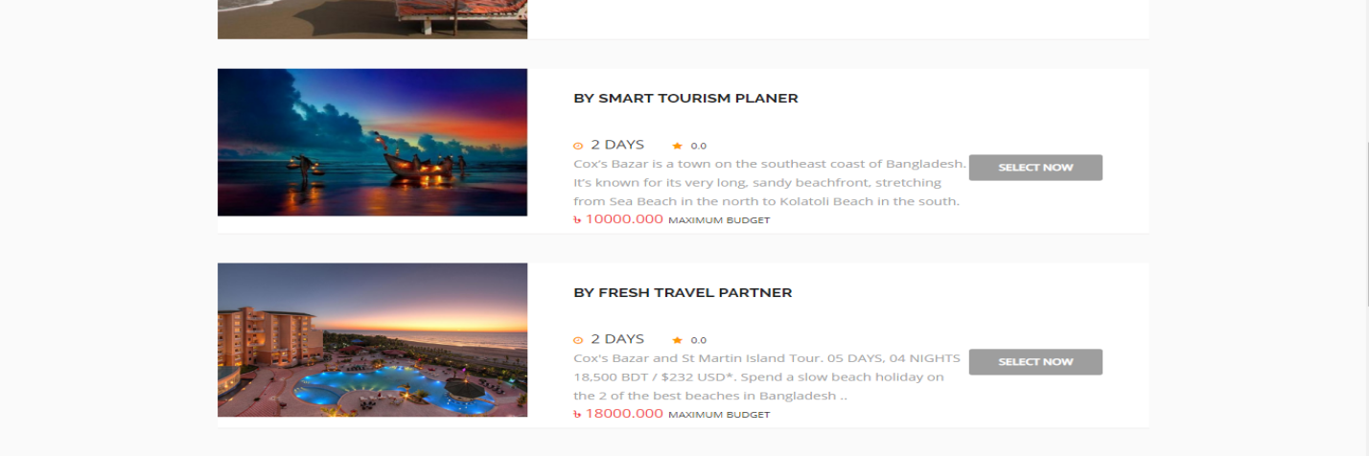

Figure 6.3: Packages

**Plan Page:** After select the package user will go to the plan page where the can see the whole plan of their tour. Where they will find out day wise plan, hotel booking page, transport page, emergency page and others.

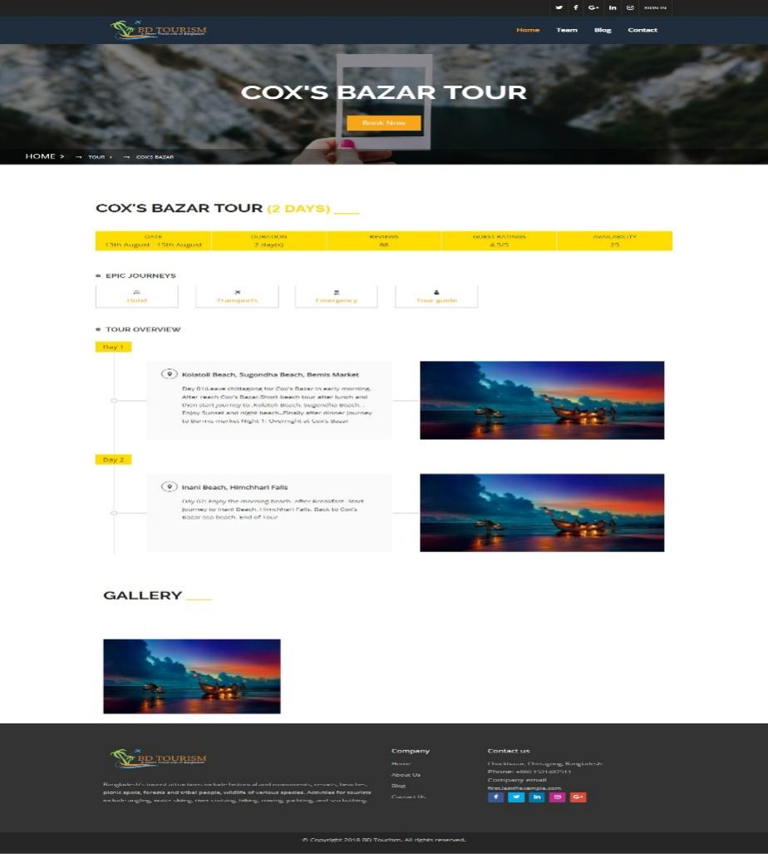

Figure 6.4: Plan Page

**Hotel Page:** After going to the hotel page user can see the best hotel related to the packages.

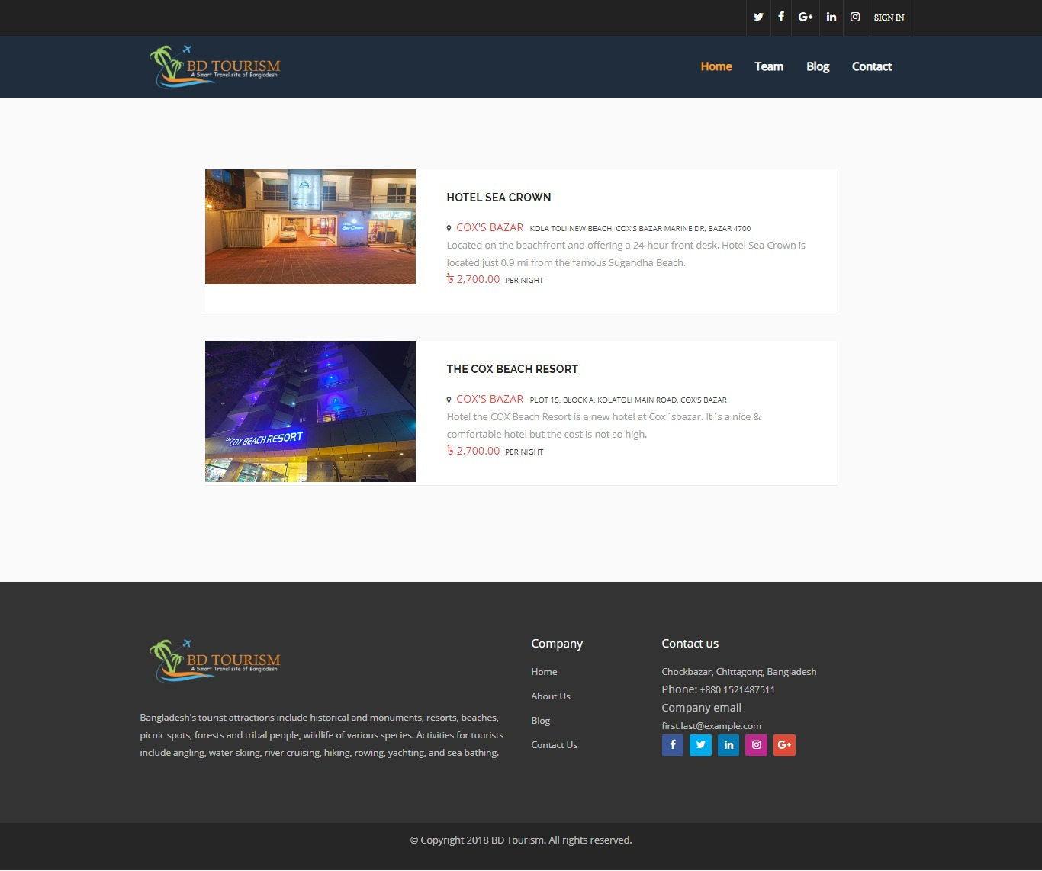

Figure 6.5: Hotel Page

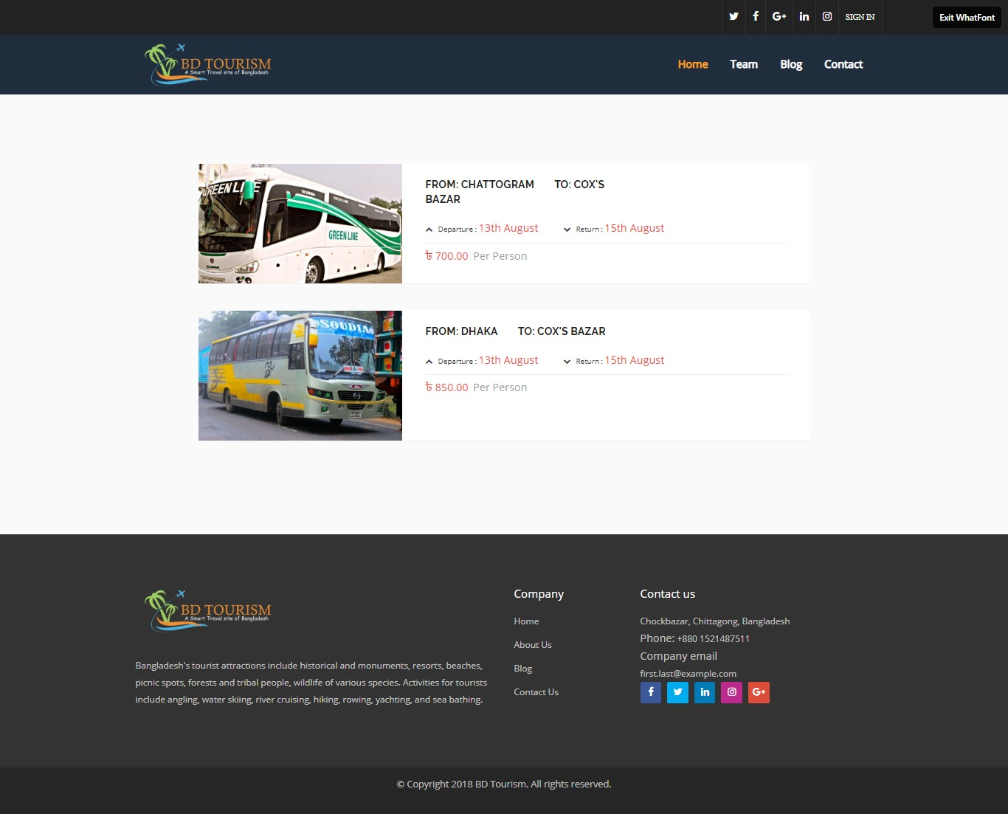**Transport Page:** After going to the transport page user can see the best transport services related to the packages.

Figure 6.6: Transport Page

**Emergency Page:** After going to the emergency page user can see the best emergency services related to the packages.

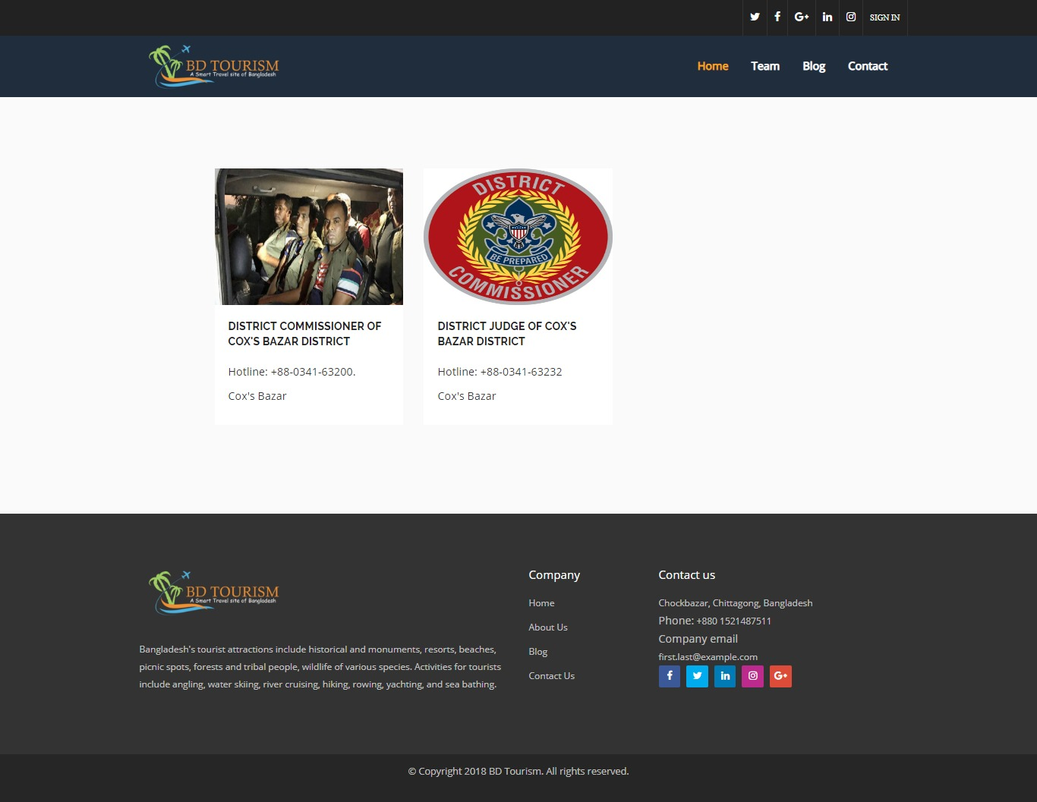

Figure 6.7: Emergency Page

**Booking Page:** In the booking page user can book their best package. Where they have to give all their information for this process.

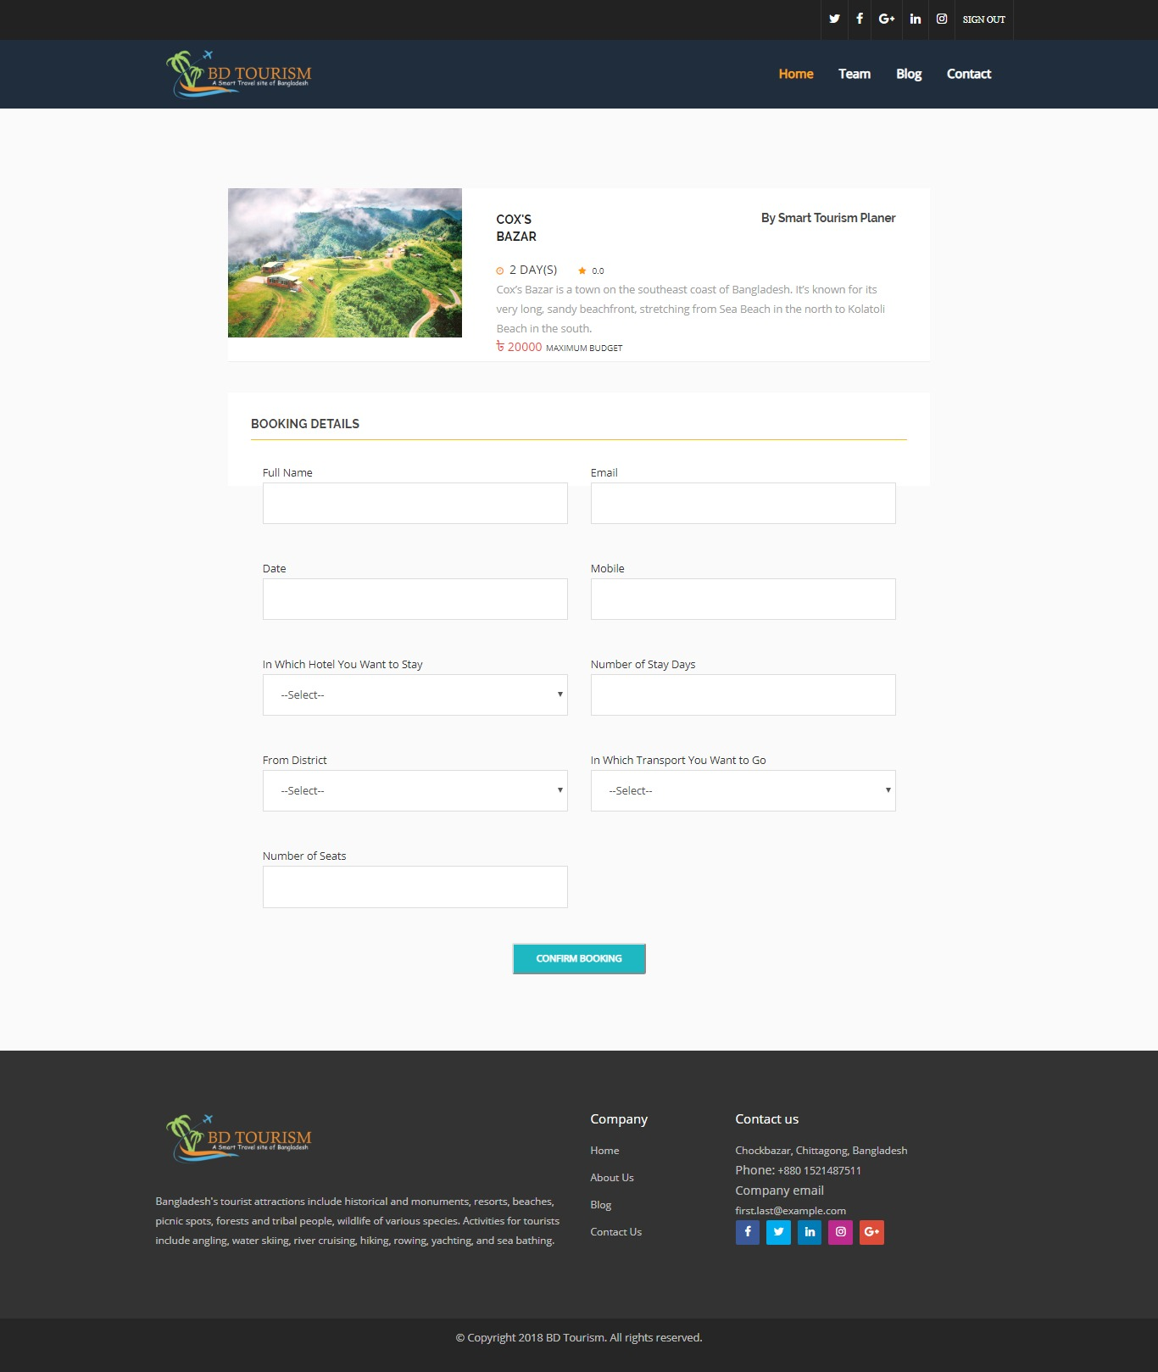

Figure 6.8: Booking Page

**Booking Confirmation Page:** After booking user will go to the confirmation page where they can see their confirmation page.

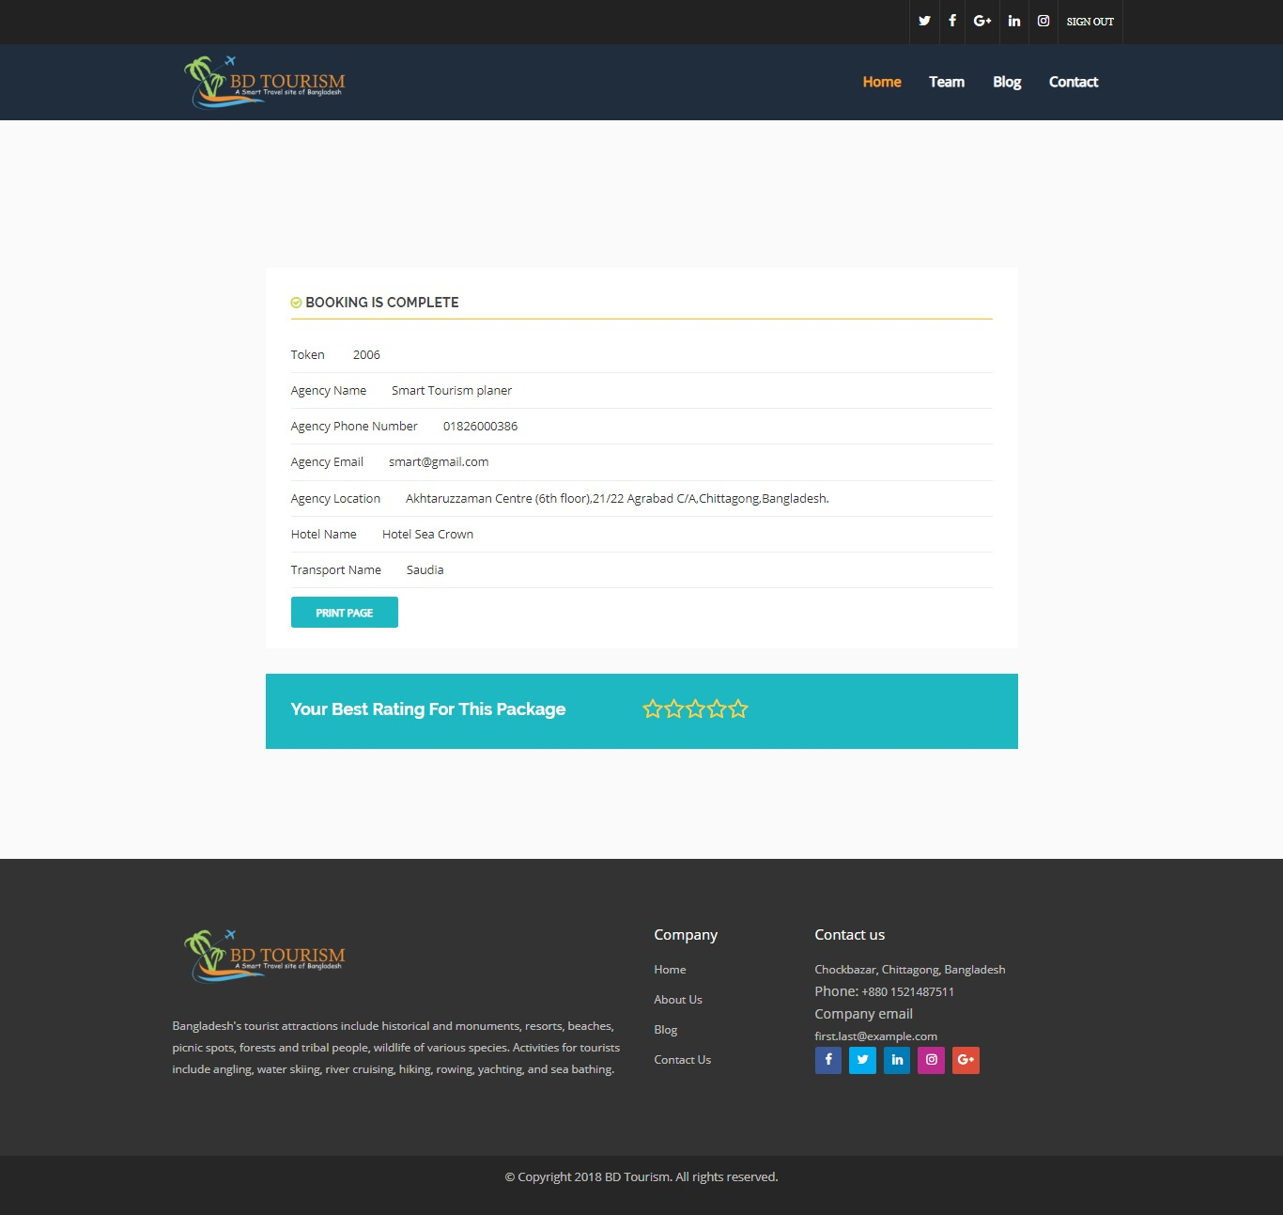

Figure 6.9: Booking Confirmation Page

**Team Page:** In team page user can see the developer information’s and contact information

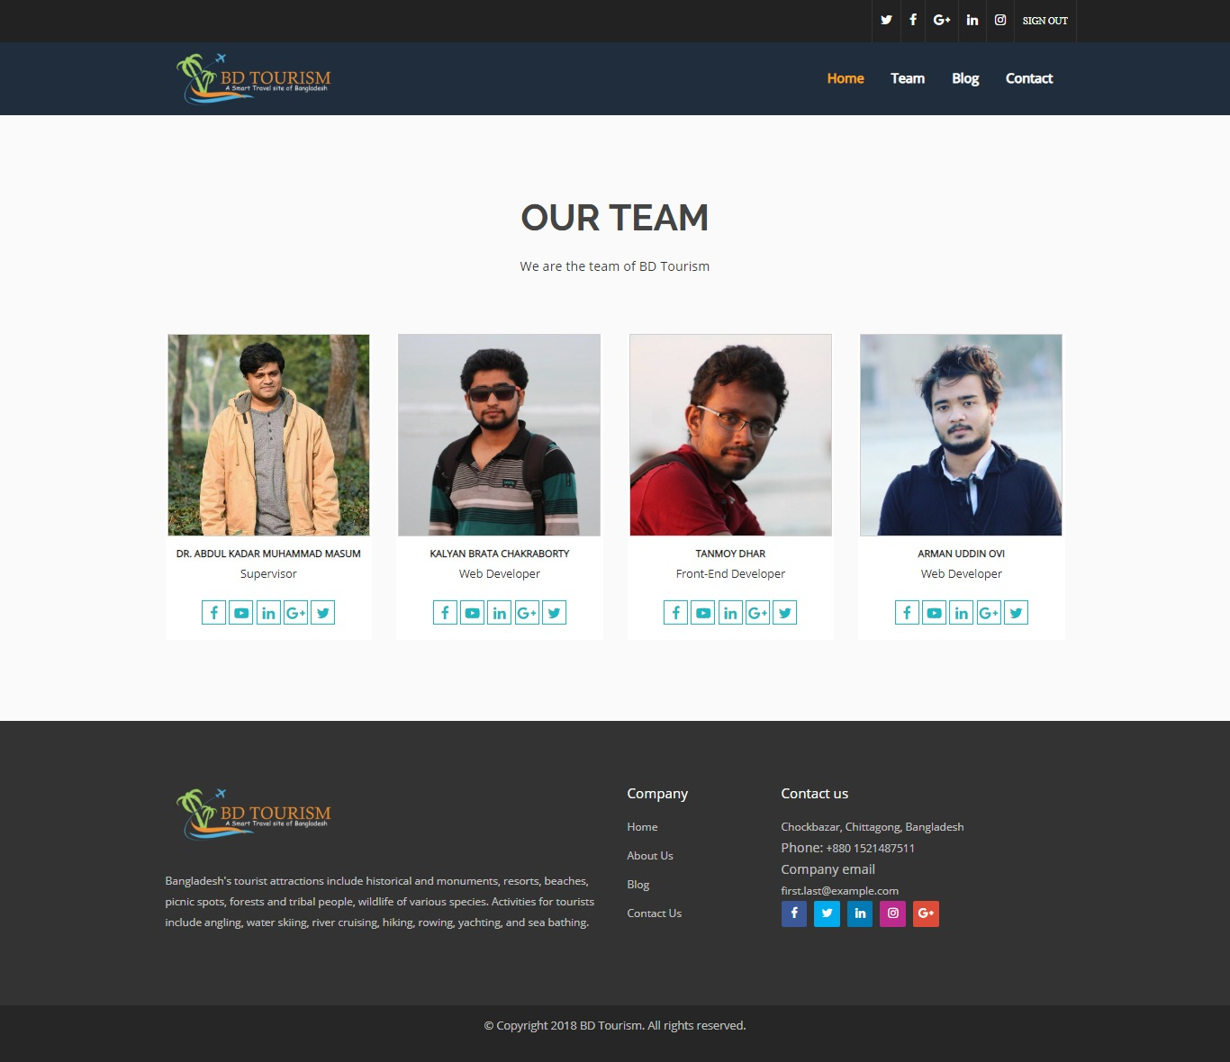

Figure 6.10: Team Page

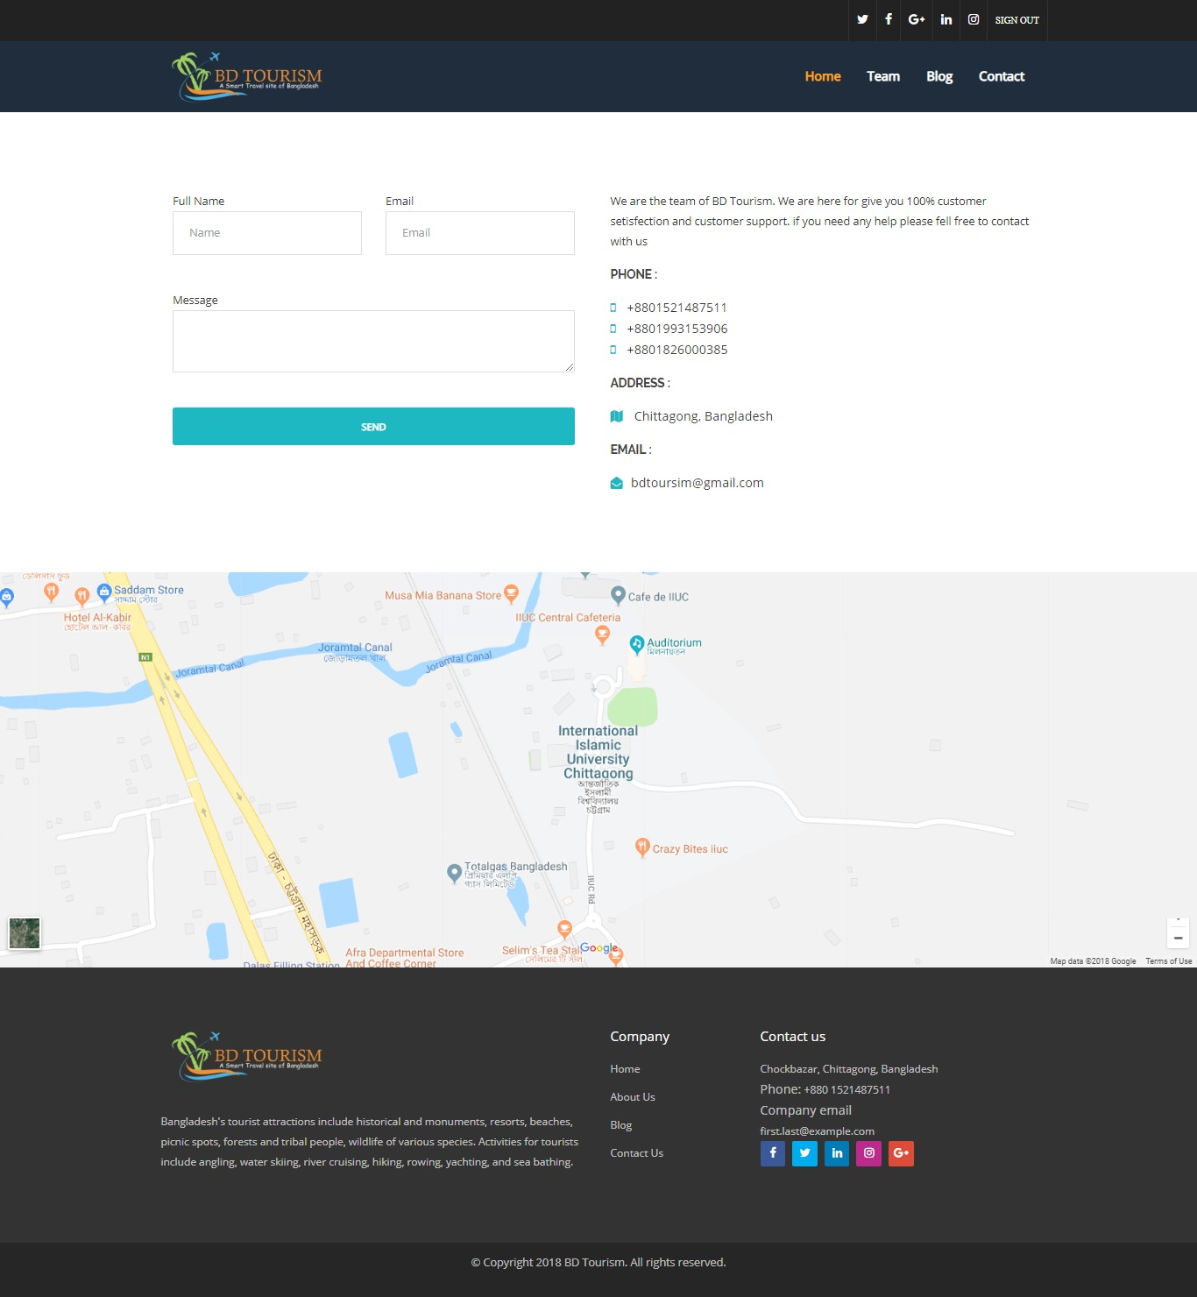**Contact Page:**  User can contact with the team and developer of the website by contact page.

Figure 6.11: Contact Page

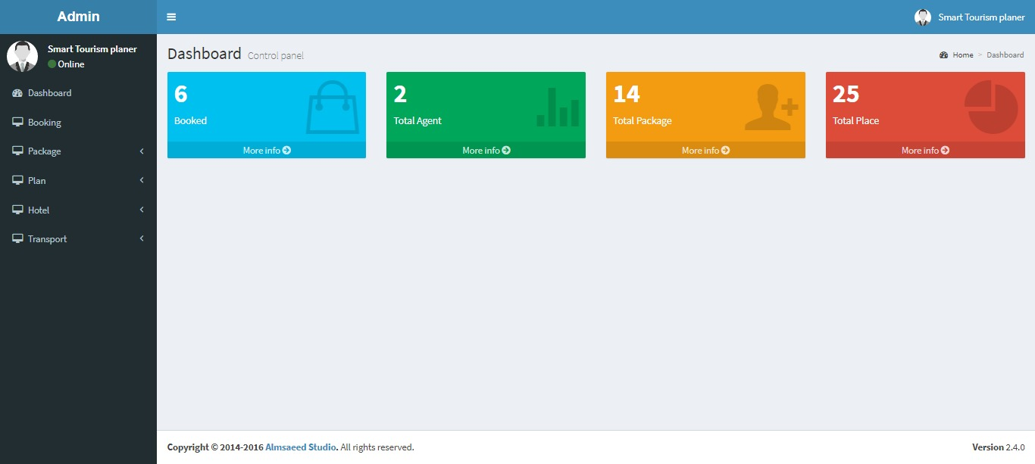**Admin Page:** In admin page admin or agent can control all the information of the website. They can add delete or edit all the information.

Figure 6.12: Admin Page

**Division Page:** In add division page admin will give all the information of the division and in the view division page admin can view all the information of the division.

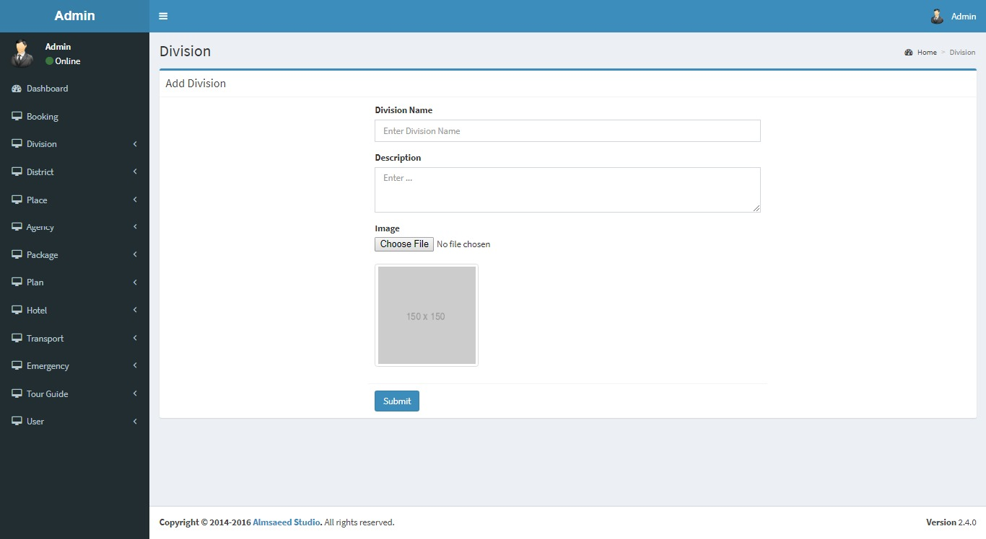 Figure 6.13: Add Division Page

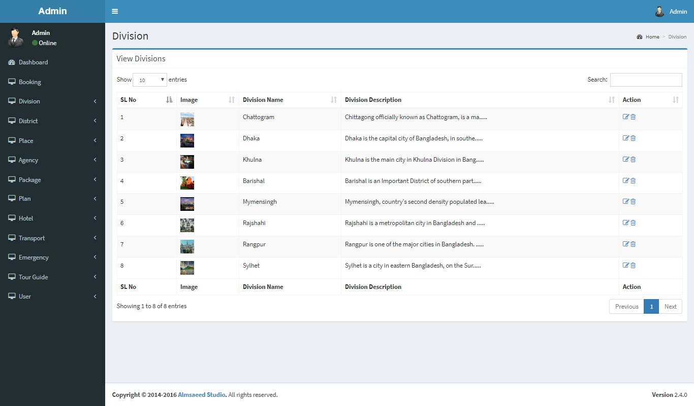 Figure 6.14: View Division Page

**District Page:** In add district page admin will give all the information of the district and in the view district page admin can view all the information of the district.

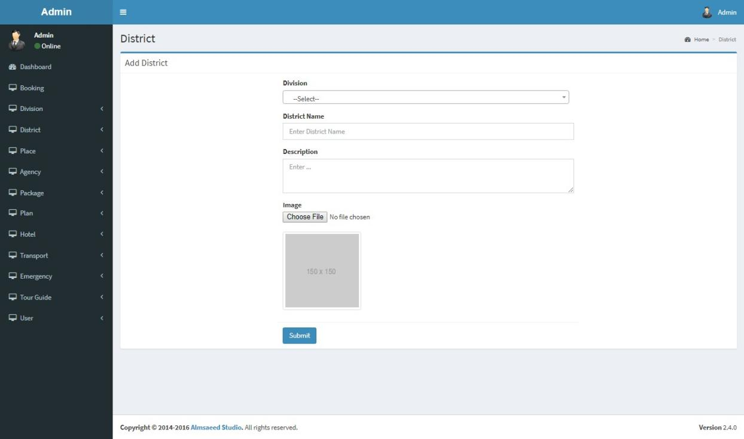

Figure 6.16: Add District Page

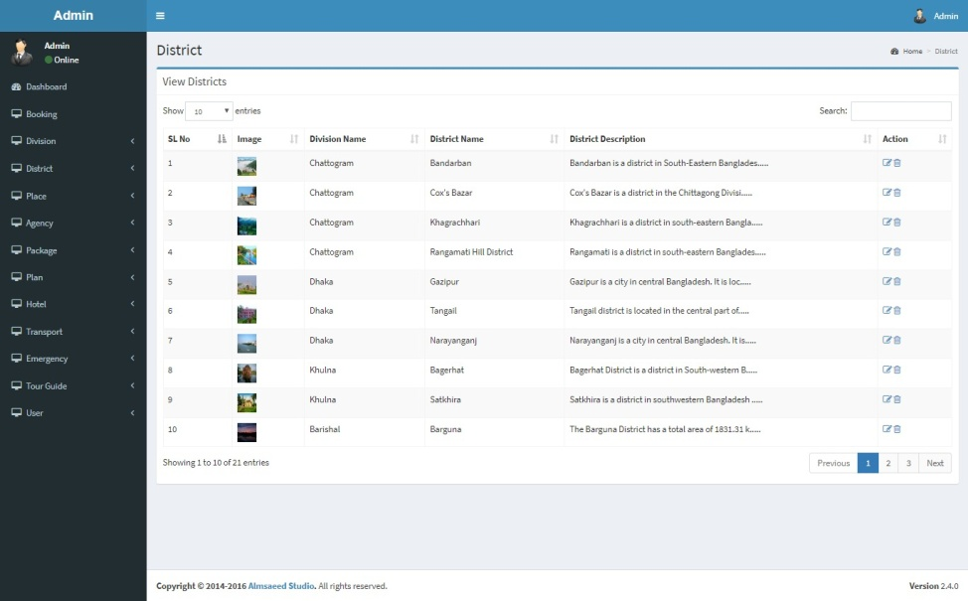

Figure 6.17: View District Page

**Place Page:** In add place page admin will give all the information of the place and in the view place page admin can view all the information of the place.

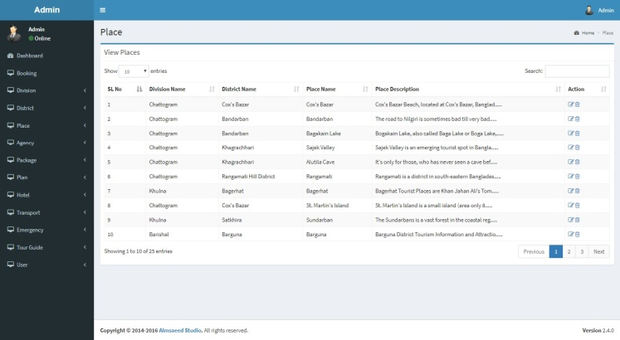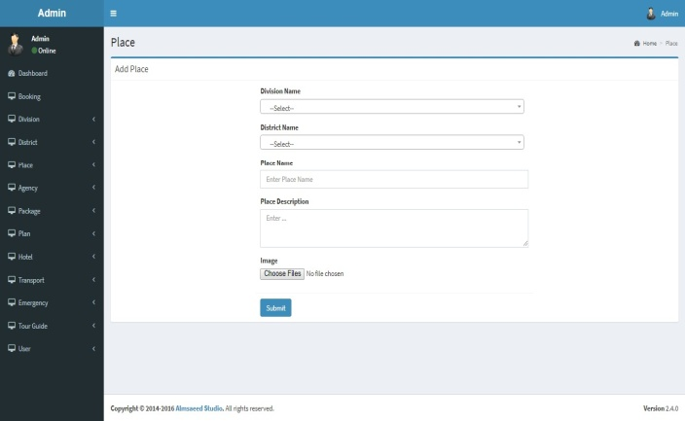

Figure 6.18: Add and View Place Page

**Hotel Page:** In add hotel page admin will give all the information of the place and in the view place page hotel can view all the information of the hotel.

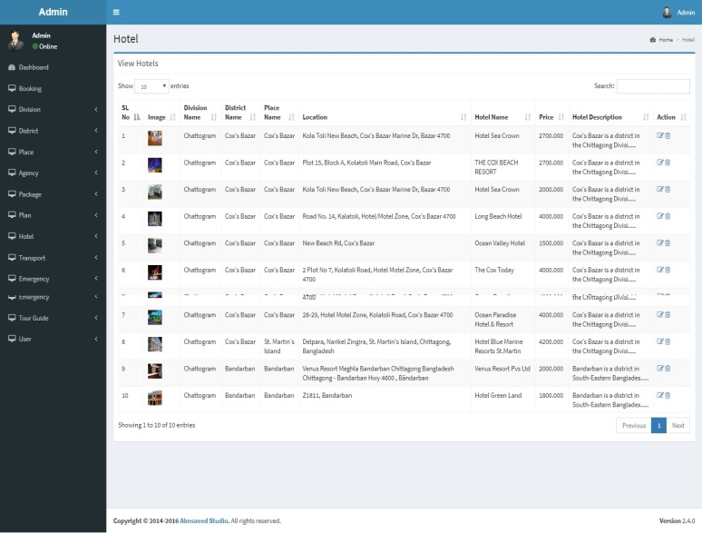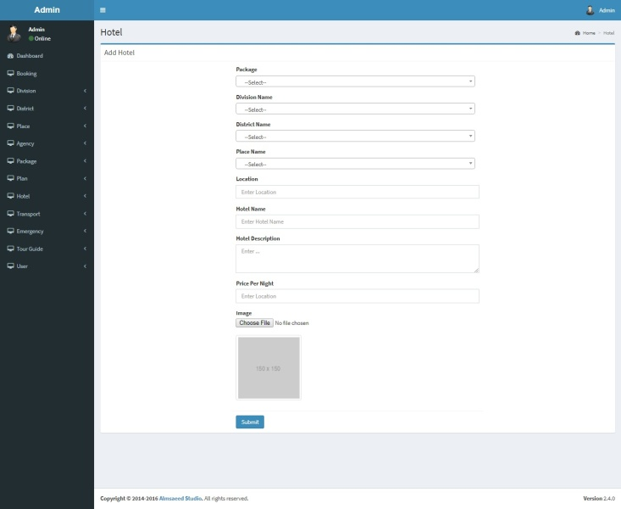

Figure6.19: Add and View Hotel Page

**Plan Page:** In add plan page admin will give all the information of the place and in the view plan page plan can view all the information of the plan.

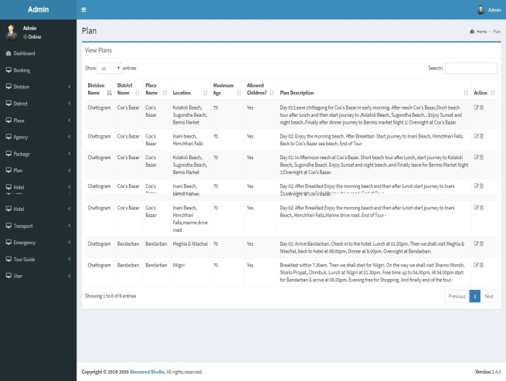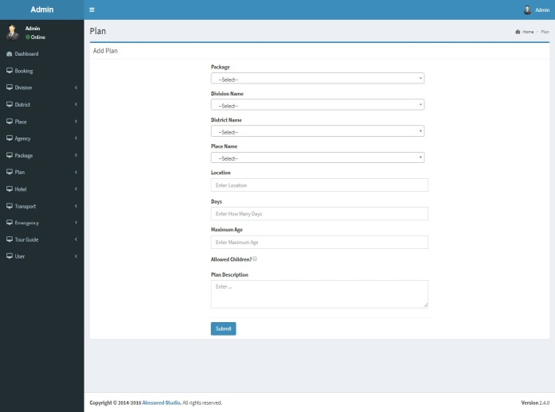

Figure6.20: Add and View Plan Page

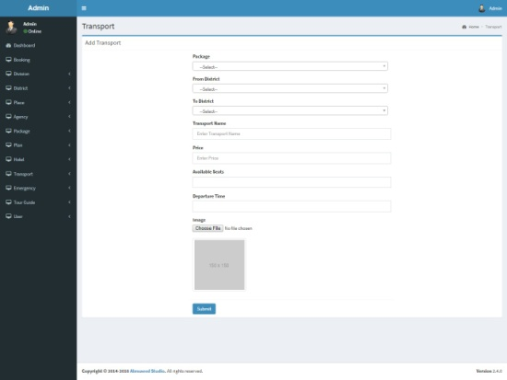**Other Pages:**

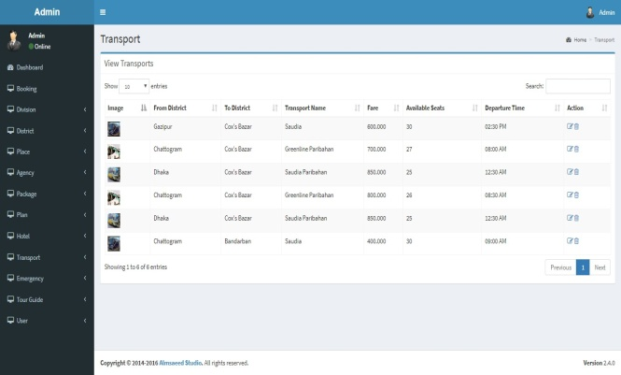

Figure 6.21: Add and View Transport Page

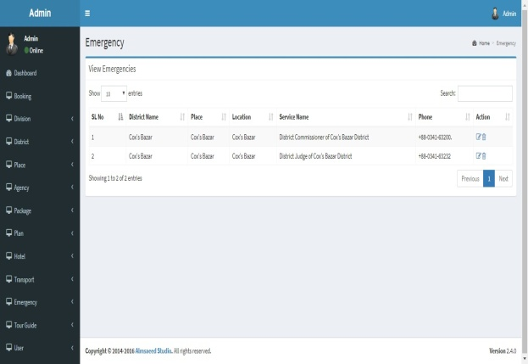

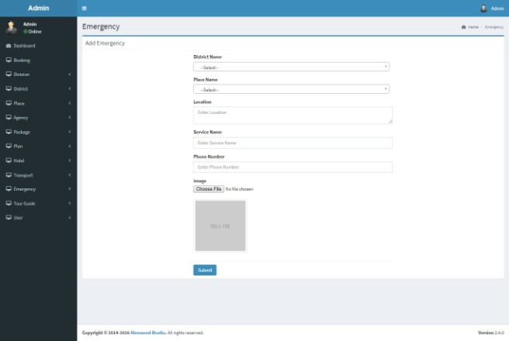

Figure 6.22: Add and View Emergency Page

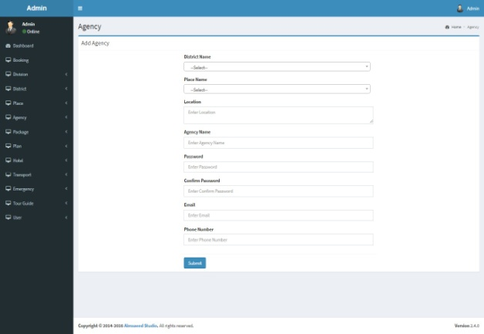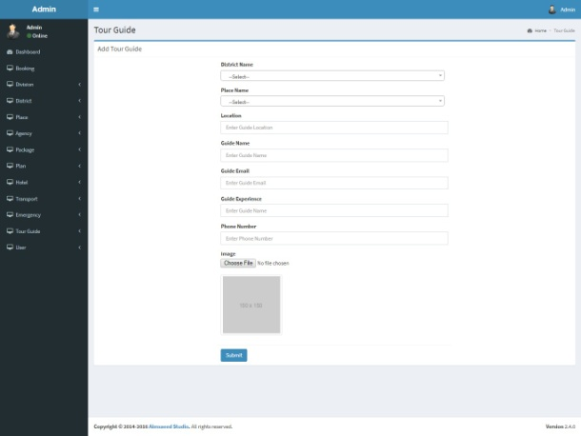

**Chapter Seven**

**TESTING**

**7.1 Introduction:**

This chapter mentions about the various testing process which is very inprotant for make a project perfect and error free. Our BD Tourism use all of this testing process one by one.

**7.2 Testing:**

One of the most important criteria of software development life is testing. testing is the way toward testing the product things to identify the contrast between given information and expected yield. Testing guarantees that product capacities are practically working as indicated by particulars, that conduct and execution necessities seem to has been met.

**7.3 Objectives of testing:**

Software testing objectives are:

* Finding defect which might get caused by the developer while developing the software.
* Getting confidence about the confident level.
* For defect removing.
* Making sure that final results met the business and user requirements.
* Gaining the customers feedbacks by providing them a quality system.

**7.4 Types of testing:**

Testing can be classified as follows:

* White box testing
* Black box testing

**7.4.1 White box testing:**

White box testing is a testing to check the internal segments of the software such as to test the coding and the user-based functionalities. White box testing is very much important for the internal testing of software.

**7.4.1.1 Advantages of White Box Testing:**

* Optimizing the code after finding hidden errors.
* White box testing is very much easy for being automated.
* White box testing is very much sufficient as all codes are covered.
* Testing can start early in SDLC even if GUI is not available.

**7.4.1.2 Disadvantages of White Box Testing:**

* White box testing is very complexive and expensive.
* White box testing sometimes causes problem for the developers as finding error out of code is difficult.
* For white box testing knowledge of the code and knowledge about the implementation is very important.
* White-box testing is time killing, larger programming application which took time to test in whole.

**7.5 White Box Testing In Our System:**

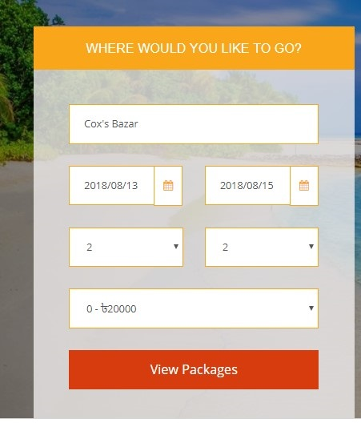

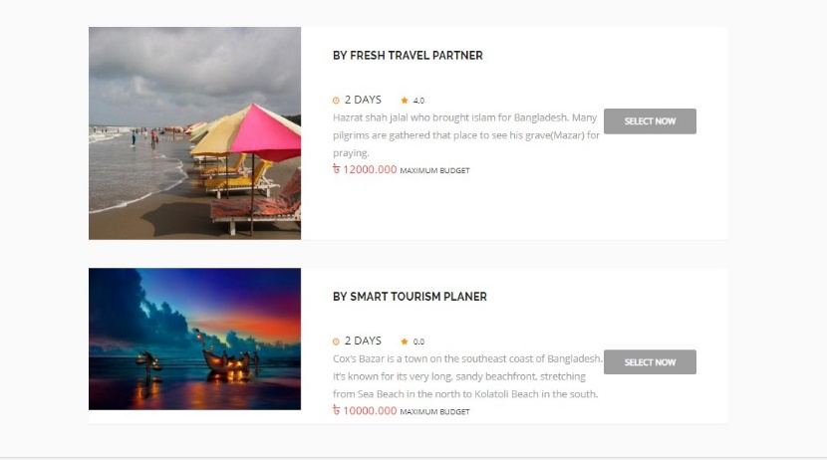

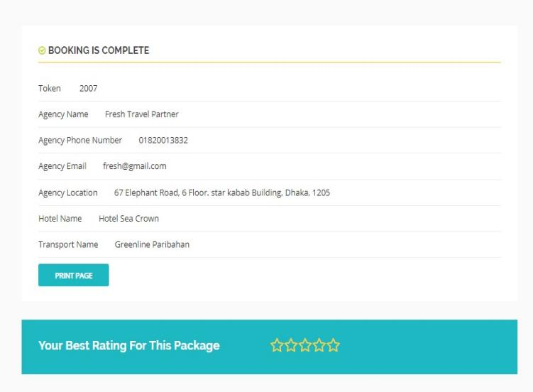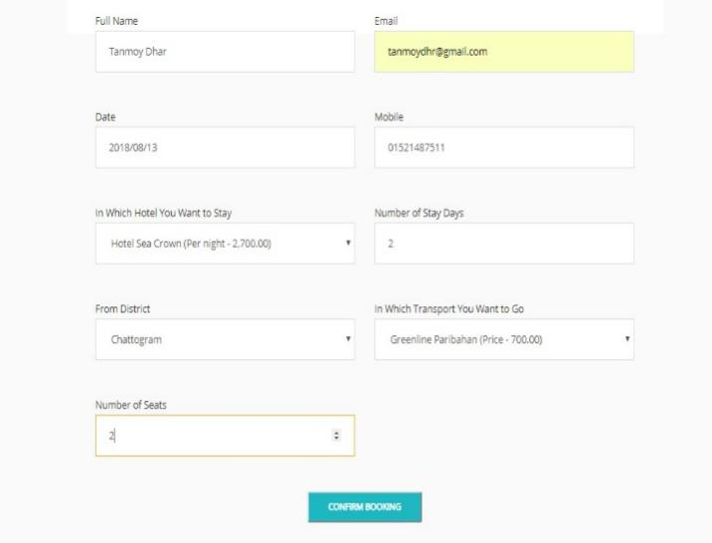

Fig 7.1: White Box Testing in Our System

**7.5.2 Black box testing:**

Black box testing is a software testing method in which usefulness of the product under test is tried without taking a gander at the interior code structure, execution subtle elements and learning of inside ways of the product. This sort of testing depends altogether on the product prerequisites and details.

**7.5.2.1 Black Box Testing – Steps:**

Here are the steps followed to carry out the Black Box Testing.

* Initial requirement and specification of the system are tested.
* Tester chooses valid inputs to check whether SUT processes them correctly. Also some invalid inputs are chosen to verify that the SUT is able to detect them.
* Tester examines outputs for all the inputs.
* All the test cases are executed.
* Tester compares the real outputs with the expected outputs.
* Defects if any output have to be corrected and tested.

**7.5.2.2 Black Box Testing Techniques:**

There are some testing that can be used for black box testing:

* **Equivalent partitioning:** It is a test technique that involves breaking input valuesinto valid and invalid partitions and selecting representative values from each partition as test data.
* **Boundary Value Analysis:** It is a test design technique that involves determinationof boundaries for input values and selecting values that are at the boundaries and just inside/ outside of the boundaries as test data.
* **Cause Effect Graphing:** It is a test design technique that involves identifying theinputs and outputs, producing a Cause-Effect Graph, and generating test cases properly.

**7.6 Black Box Testing In Our System:**

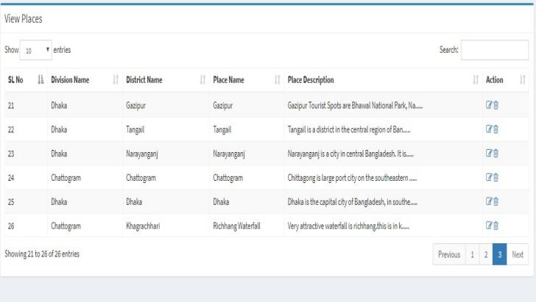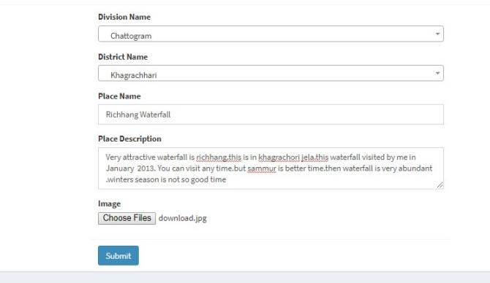

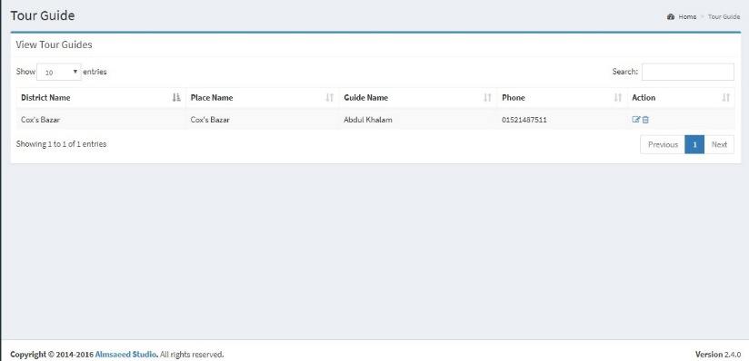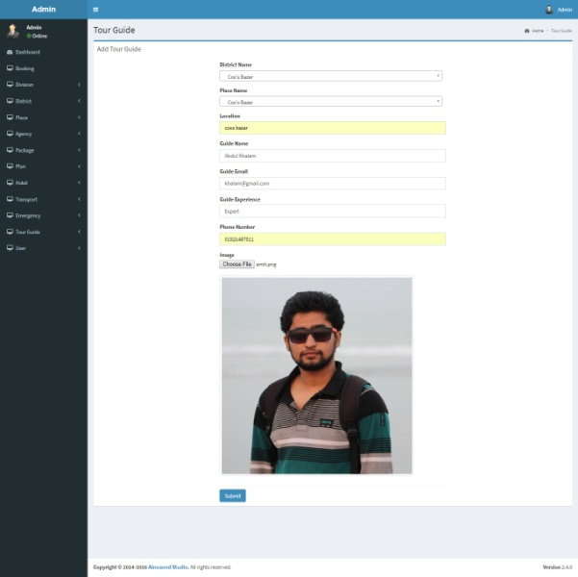

Fig 7.2: Black Box Testing in Our System

**7.6 Summary:**

In this chapter we have discussed about the testing criteria of the software. There is white box testing for the internal structure and black box testing for the external structure. Software testing is very important for software development.

**Chapter Eight**

**MAINTENANCE OF THE SYSTEM**

**8.1 Introduction:**

Studies of maintenance phase of software development have revealed enormous costs, generally, exceeding the development cost. In addition, in most cases the maintenance data include the cog of rewriting, testing, debugging and integrating new ligatures into the software. Sometimes such cost is called modification or enhancement costs and treated as separate and distinct from maintenance caws. However, in practice they are lumped together. In both cases, the maintenance or modification costs are strongly related to the quality of the documentation.

**8.2 Maintenance:**

Software Development has many phase, these stage incorporate Requirement Engineering. Architecting, Design, Implementation, Testing. Programming Development and Maintenance. Upkeep is the last phase of the product life cycle. After the item has been discharged, the upkeep stage stays up with the latest with condition changes and changing client prerequisites. In spite of the fact that product does not product out, it needs upkeep for the accompanying reasons:

* It was delivered bugs. The bugs may be coding error, design error or analysis error.
* The environment in which the software operates may change. For example: The operating system may change or hardware platform may change
* The customer requirement may change. **For example:** The software requires new features. Therefore, software needs maintenance.

**8.3 Classification of maintenance:**

* Corrective Maintenance
* Adaptive Maintenance
* Perfective Maintenance
* Preventive Maintenance

**8.4 Description of Maintenance:**

**Corrective Maintenance:** Corrective maintenance can be defined as a maintenance undertaking performed to distinguish, confine, and correct a blame so the fizzled hardware, machine, or resource can be reestablished to an operational condition inside the resistances or breaking points built up for in-benefit tasks.

**Adaptive maintenance:** Modification of a software product performed after delivery to keep a software product usable in a changed or changing environment.

**Perfective maintenance:** Modification of a software product after delivery to improve performance or [maintainability](https://en.wikipedia.org/wiki/Maintainability" \o "Maintainability).

**Preventive maintenance**: Modification of a software product after delivery to detect and correct latent faults in the software product before they become effective faults.

**8.5 Summary:**

In this chapter we have discussed about the maintenance of the software. There are many steps of software maintenance which are very much important and helps the developer to maintain their software.

**Chapter Nine**

**CONCLUSION**

**9.1 Introduction:**

This chapter mentions about the various issues which had been discussed in previous chapters. Our BD Tourism System is an application which helps the travelers to make their trips more easy and smart.

**9.2 Project Outcomes:**

We have mentioned all the features and functions to develop the system. We have discussed the development process of the system in previous chapters.

* In this project, Firstly agency can register or admin can create agency and the modules will be provided for different agency.
* Secondly agency will login for different modules.
* Thirdly user can see the plan and book the agency.
* Finally, agency can get the booking information of their own and admin can get all the booking information.

**9.3 Project Limitations:**

There are some limitations in our project. They are:

* The system has no direct booking system for the hotel and transport.
* This system is only cover Bangladeshi tourist spots.
* No mobile application of the system has been made.

**9.4 Future works:**

Some of the future work of the project below there:

* We will directly make a deal for the hotels and transports.
* Android system will be added in the software.
* Every kind of information about booking through SMS.
* We will make this application for international purpose.

**Chapter Ten**

**REFERENCES**

1. <https://www.makemytrip.com/>
2. <https://www.tripadvisor.com/>
3. <https://www.lonelyplanet.com/>
4. <https://www.yatra.com/>
5. <https://www.travelguru.com/>
6. [www.bangladesh.com/travel-guide/](http://www.bangladesh.com/travel-guide/)
7. Software Design center(2006), “How to Draw Data Flow Diagrams”, 2006,
8. Collected form <https://www.smartdraw.com/diagrams/>
9. <https://www.wikipedia.org/>
10. <https://youtube.com>
11. <https://google.com>